Lecture 1: Overview of Financial Management
What is Financial Management?
- Study how companies conduct their businesses in order to maximise value
Forms of a Business Organisation
- Proprietorship: Unincorporated business owned by 1 individual
Unincorporated: Not formed into a legal corporation
- Partnership: Unincorporated business owned by 2 or more persons
- Corporation: Incorporated business owned by many shareholders
  - A legal entity that is separate from the owner
  - Eg. Bill Gates doesn’t pay for Microsoft and vice versa
  - Ownership is denoted by shares
  - Can be public or private
Proprietorships and Partnerships
Unlimited liability: May lose more than what they invested (Still need to pay debt using assets)
- Advantages: Ease of formation, subject to few regulations, no corporate income tax (although there is still personal income tax)
- Disadvantages: Difficult to raise capital, unlimited liability, limited life
Corporation
- Advantages: Easy transfer of ownership, unlimited life, limited liability, ease of raising capital
- Disadvantages: Cost of set up and report filing, double taxation
  - Double taxation means to tax on both corporate level and personal level (Dividends are taxed!)
  - In Singapore, there is no double taxation because dividends are not taxed
Structure of a Corporation (Publicly-traded corporation)
- Shareholders who own shares of the company
- Board of Directors whose fiduciary duty is to represent shareholder’s interest and are elected by the shareholders
- Management (CEO), who runs the company on behalf of the shareholders
Goals of a Corporation
- Primary financial goal is shareholder’s wealth maximization – maximize the intrinsic value of the stock in the LR
Why not maximise accounting profits?
*In evaluating investment decisions, analysts focus on 3 key factors; Cash flows, time & risk
Closely held corporation; Corporation that is owned by a few individuals who are typically associated with the firm’s management
Stock Prices and Intrinsic Value
- Market/Stock price: Set by the marginal investor based on her perceived value of the stock (Depends on the demand/supply in the market)
- Intrinsic Value: An estimate of the “true” value based on the best available information
  - A LR concept
  - Investors will try to estimate the intrinsic value of the stock and come up with different estimates (use different systems and methods)
- A stock’s price in the short run may deviate from the intrinsic value
  - Can be overvalued or undervalued, then the company will sell/buy
  - (Refer to diagram on next page)
Market price > Intrinsic value (OVERVALUED = DON’T buy, may sell)
Market price < Intrinsic value ( UNDERVALUED = BUY!)
Market price = Intrinsic value (EQUILIBRIUM = No tendency to buy/sell)

- In equilibrium, a stock’s price should = intrinsic value
  - Equilibrium means a situation where investors are indifferent btw buying and selling a stock (No tendency to buy/sell)
- Ideally, managers should avoid actions that will decrease the intrinsic value even if those decisions increase the stock price in the short run (Long run concept!)
Agency Problems
For a company to expand, they’ll buy other companies (diversification). But if managers just keep buying but no use = worsen the company’s situation = AGENCY PROBLEM
- Conflicts between shareholders and managers
- Managers are naturally inclined to act in their own best interests
- Eg fixed salary/commission – fixed: no motivation to work hard
Solving Agency Problems
- Managerial compensation packages
  - To reward managers based on the long-run intrinsic value of the stock
- Direct intervention by shareholders
- Threat of firing
- Threat of takeover

SR and LR are very important keywords in MCQ!
Required returns > Expected returns = Overvalued (R>E=0 REO)
*Annual report contains four financial statements: Income statement, balance sheet, cash flow statement, statement of shareholders’ equity
Lecture 2: Time Value of Money
What is the time value of money?
- The idea that money available today is worth more than the same amount in the future because you can invest the money
  - Deposit to earn interest
  - Invest in stocks and bonds
- Compounding: The process of finding the FV of a cash flow or series of cash flows
Compounding = Find FV of CFs
- Discounting: The process of finding the PV of a cash flow of series of cash flows
Discounting = Find PV of CFs
- Standard formulas:
  - FV_{N} = PV (1+I)^{N} (Compounding)
  - PV = FV_{N} / (1+I) (Discounting)
  - (Or just use the calculator to enter the values)
Ordinary Annuity, Annuity Due and Perpetuity
Annuity: Series of equal cash flows at fixed intervals for a specified no of periods
Ordinary Annuity
- Ordinary Annuity: Cash flows occur at the end of the period
- Standard formulas:
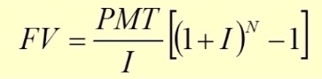

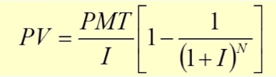

Annuity Due
- Annuity Due: Cash flows occur at the beginning of the period
FV and PV of both Annuity
- For both PV and FV, annuity due will always be greater than ordinary annuity (ANNUITY DUE > ORDINARY ANNUITY!)
  - FVA_{due} earns one more period of interest
  - PVA_{due} is discounted one period less
- FVA_{due} = FVA_{ord}(1+I)
All annuity due need to x (1+I)!
- PVA_{due} = PVA_{ord}(1+I)
Perpetuity
- An annuity that lasts forever
- PV = PMT/I
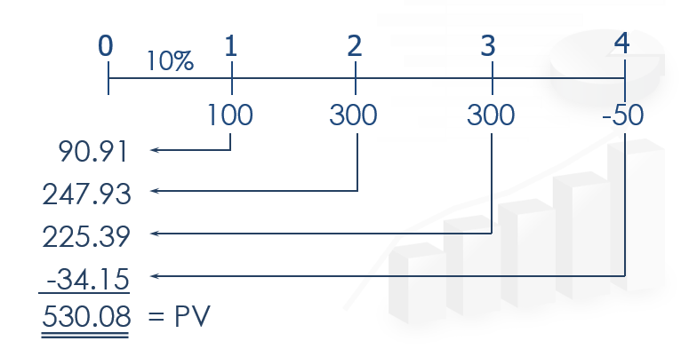
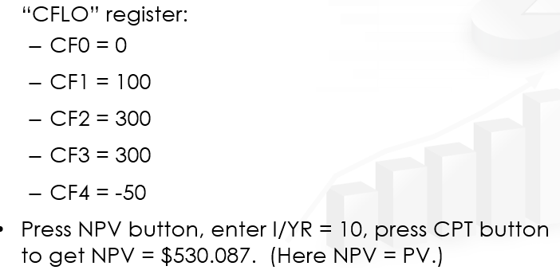
Uneven cash flow stream can be solved too!

100/1.1 = 90.91, 300/(1.1)^2 = 247.93
Q: Will the FV of a lump sum be larger or smaller if compounded more often, holding the stated I% constant?
LARGER, as the more frequently compounding occurs, interest is earned on interest more often
Classifications of Interest Rates
Nominal Rate (I_{NOM})
Nominal Rates are always given in the qn
- Also called the quoted or stated rate that is stated in contracts with a given period
- An annual rate that ignores compounding effects
- I_{NOM} are written into contracts, quoted by banks or brokers and not used in calculations
Periodic Rate (I_{PER})
Iper = Inom/M
- Amount of interest charged each period, e.g. monthly or quarterly.
- I_{PER} are used in calculations and shown on time lines
I_{PER} = I_{NOM}/M, where M is the number of compounding periods per year. M = 4 for quarterly and M = 12 for monthly compounding
Effective Annual Rate (EAR = EFF%)
- The annual rate of interest actually being earned, accounting for compounding.
Used to compare returns on investments with different payments per year
Eg. EAR for monthly compounding is greater than the EAR for annual compounding. Thus, you should borrow money from a bank that compounds interest annually
- Eg. EFF% for 10% semiannual investment is:
  - EFF% = (1 + I_{NOM}/M)^{M} – 1
= (1 + 0.10/2)² – 1 = 10.25%
- Why is it important to consider effective rate of returns?
  - Investments with different compounding intervals provide different effective returns
  - To compare investments with different compounding intervals, you must look at their effective returns (EFF% or EAR)
- EAR is used to compare returns on investments with different payments per year
*Don’t confuse with FVn = PV(1 + i)^n

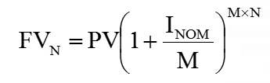

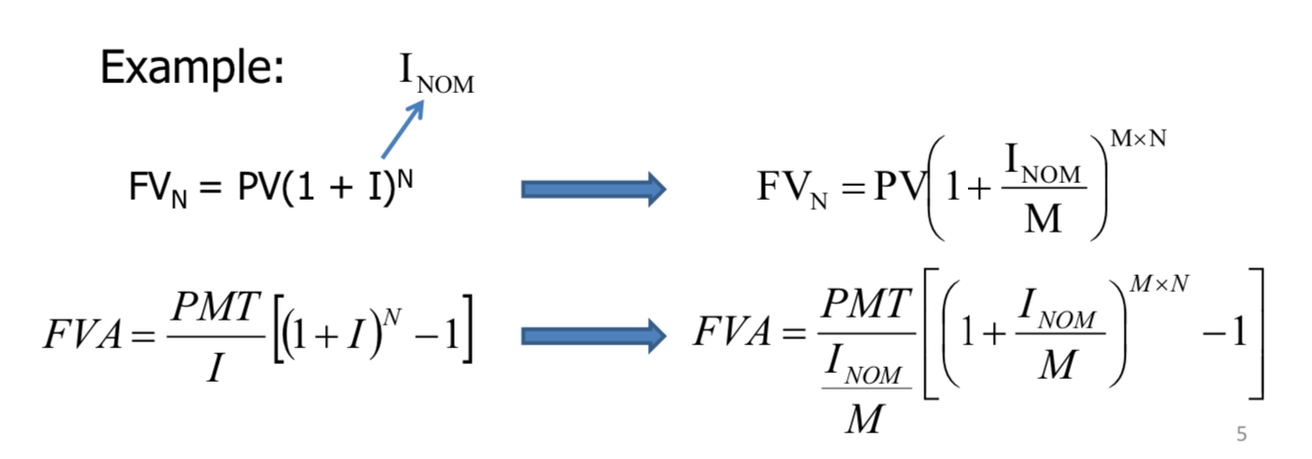

When to use Iper, when to use EFF/EAR?
- Use Iper when compounding period and PMT period is the same (e.g. interest compounded monthly, and PMT also given monthly)
- Use EAR when different (e.g. compounded semi-annually but PMT given monthly) or (compounded monthly but PMT only for 10/12 months in a year)
*Interest is compounded once a year -> Annual nominal interest rate = Annual effective interest rate
Loan Amortisation
- A loan that is repaid in equal payments over its life
- Eg. If loan $1000 with annual rate of 10%, how much do I need to pay at the end at each of the next 3 years?
  - Step 1: Find the Required Annual Payment (PMT)
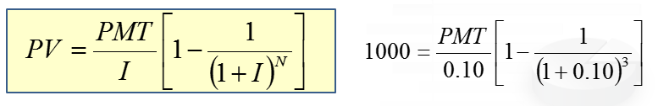
    - Write out the formula first (required)

    - FV = 0 because the reason for amortizing the loan and making payments is to retire the loan
    - Using a calculator, find the PMT (which is the principle + interest for that yr)
  - Step 2: Find the Interest Paid in Year 1
    - Interest = Beg Bal (I)
  - Step 3: Find the Principal Repaid in Year 1
    - Principal = PMT - Interest
  - Step 4: Find the Ending Balance after Year 1
    - End Balance = Beginning Bal – Principal
- Repeat the 4 steps until the end of loan
- The outstanding principal (End Bal) is the PV of all future payments (Beg Bal)
Loan principle = PV of all remaining mortgage (payments)
- An amortisation table will be constructed
  - Interest paid declines with each payment as the balance declines
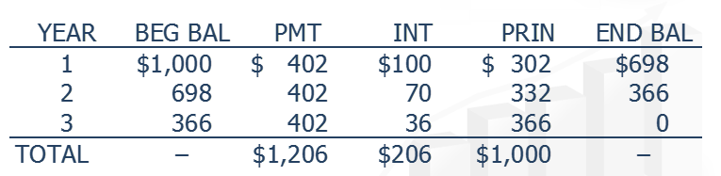

From the table,
Interest = 10% of beginning balance
Principle = PMT – INT
End bal = Beg balance - Principle
*END BALANCE = BEG BAL OF FOLLOWING YR

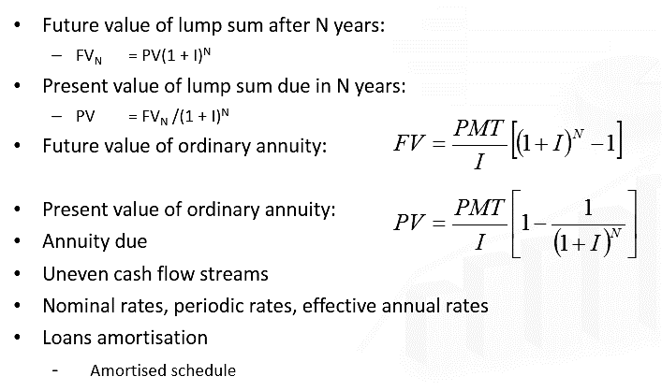
Summary

RMB FV/PV OF ANNUITY DUE = ORDINARY ANNUITY OF FV/PV x (1 + I)

Lecture 3: Financial Markets & Institutions, Financial Statements, Cash Flow, Taxes, I/R
Capital Allocation Process
- In a well-functioning economy, capital flows efficiently from those who supply capital to those who demand it
If have excess capital, how to spend?
  - Suppliers: People with “excess funds”, who are saving and looking for a rate of return on their investment
  - Demanders: People who need to raise funds, willing to pay a rate of return on the capita they borrowed
Transfer of Capital

Direct Transfer
*No middlemen
$ goes directly from saver to borrower

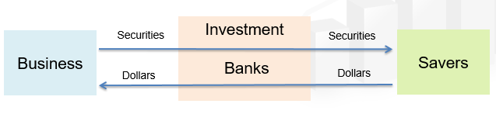
Investment Banks

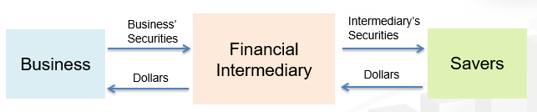
Financial Intermediaries

Financial Markets & Institutions
- A financial market is a place where individuals and organisations wanting to borrow funds are brought together with those having a surplus of funds
Types of Financial Market
Physical Assets | Financial Assets
‘Tangible’/’Real’ assets  Products such as wheat, real estate, computers | Stocks, bonds, notes, mortgages, derivative securities whose values are derived from changes in the prices of other assets  *Option to buy a stock = Derivative security
Primary | Secondary
Markets in which corporations raise new capital | Existing, already outstanding securities are traded among investors after being issued by corporations
Public | Private
Standardized contracts are traded on organized exchanges | Transactions negotiated between 2 parties  Private equity companies typically invest in shares of privately held companies
Money | Capital
Markets in which funds are borrowed or loaned for a short period (<1yr)  Eg. Treasury bills, consumer credit | Stocks, and intermediate and long-term debts (maturity >1yr)  Eg. Treasury notes, common stock & capital market
Spot | Future
Assets bought/sold on-the-spot | Agree to buy/sell assets at some future date
Bonds generally have lower risks compare to stocks. US treasury bills usually have lower maturity than US treasury bonds and hence present lower risks. Preferred stocks are ranked above common stocks when corporate makes payments. Hence preferred stocks usually have lower risks compared with common stocks.
    - (Riskiest) Common stocks > Preferred Stocks > Corporate bonds > US T-bonds > US T-bills (Least risky)
Types of Financial Institutions
- Commercial banks; ‘Traditional stores of finance’ -> Serves variety of savers & borrowers Eg. Citibank
- Investment banks; Help companies to raise capital by
- Helping corporations design securities with features attractive to investors
- Buy securities from corporations
- Resell to savers
*Organization that underwrites and distributes new investment securities
- Pension funds; Retirement plans funded by corporations/government agencies for workers & administrated by trust departments of commercial banks/life insurance companies -> Invests primarily in bonds, stocks, mortgages & real estates
- Mutual funds; Accept $ from savers & use the $ to buy stocks, long term bonds/short term instruments issued by business/government units -> Pool funds & reduces risk by diversification
- Exchange traded funds (ETF); Operated by mutual fund companies
***Similar to mutual funds; ETFs buy a portfolio of stocks of a CERTAIN type!
- Hedge funds; Accept $ from savers & use funds to buy various securities
Mutual funds & ETFs | Hedge funds
REGULATED by securities & exchange commissions (EC) | UNREGULATED (Less regulation)
Targets SMALL investors | Targets LARGE investments
 | Marketed primarily to institutions & individuals with HIGH NET WORTH

- Private equity companies; Private equity players buy (mostly borrowed) & manage entire firms
***Similar to hedge funds
*Actively managed funds try to outperform the overall market by picking and choosing investments
*Index funds are passively managed because the portfolio manager of each index fund is replicating the index.
*2 main types of corporate securities; Debt securities & equity securities.

Financial Statement and Taxes
Free Cash Flows (FCF), Market Value Added (MVA), Economic Value Added (EVA) are excluded from the syllable
Financial Statement
- Balance sheet – Provides a snapshot of a firm’s financial position at one point in time
*Asset = Liability + Equity
- Income statement – Summarises a firm’s revenue and expenses over a given period of time
*Sales – Operating costs = Operating income
Operating income – interest – taxes = Net income
- Brief note on taxes
*In the balance sheet, Common stock + Retained earnings = Common Equity (Common + Preferred stock = Share Capital)
- Other data in the income statement:
DPS = TOTAL DIVIDENDS/COMMON SHARES OUTSTANDING
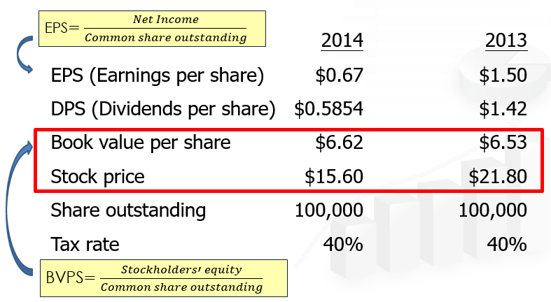

Income Tax
- Tax treatment of interest and dividends paid by corporations
  - Interest paid – Tax-deductible for corporations
  - Dividends paid – Paid out of after-tax income (Income after taxes is divided out)
- Taxes on dividends and capital gains received by investors
  - Investors pay tax on the dividends received and on their capital gains (Double taxation; US investors pay tax on dividends)
Interest Rates
In the US, not usually in SG
- 4 factors affecting the level of interest rates:
  - Risk
  - Production opportunities
  - Expected inflation
  - Time preferences for consumption (Savers willing to defer consumption & save for the future consumption -> I/R relatively lower)
Nominal vs Real I/R
- r* – The “real” risk-free rate of interest (zero expected inflation)
  - Affected by the time preference for consumption and production opportunities
- r – Any nominal rate
- r_{RF} – The rate of interest on Treasury Securities; R = r* + IP + MRP
  - Borrowings by US government are considered default-free and liquid
  - rRF represents nominal risk-free rate
Determinants of I/R
R = r* + IP + DRP + LP + MRP
Risk Factors

- r – required return on a debt security (nominal rate, takes into acc expected inflation)
- r* – real risk-free rate of interest, zero inflation
- IP – Inflation Premium
  - Average expected inflation over life of debt security (e.g. bonds)
- DRP – Default Risk Premium
  - Compensation for possible default
  - Default is when the issuer will not pay interest and principal on time and at the stated amount
- LP – Liquidity Premium
  - Compensation for possible difficulty selling debt security quickly at fair market value
- MRP – Maturity Risk Premium
  - Compensation for possible loss in value due to increase in interest rates over maturity of debt security
  - Affects longer time security more than shorter term
  - The longer the maturity, the higher the MRP
***DRP & LP go together
NOTE: NEGATIVE relationship between i/r & bond price
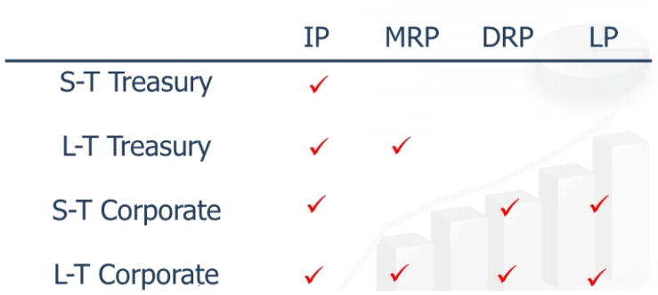

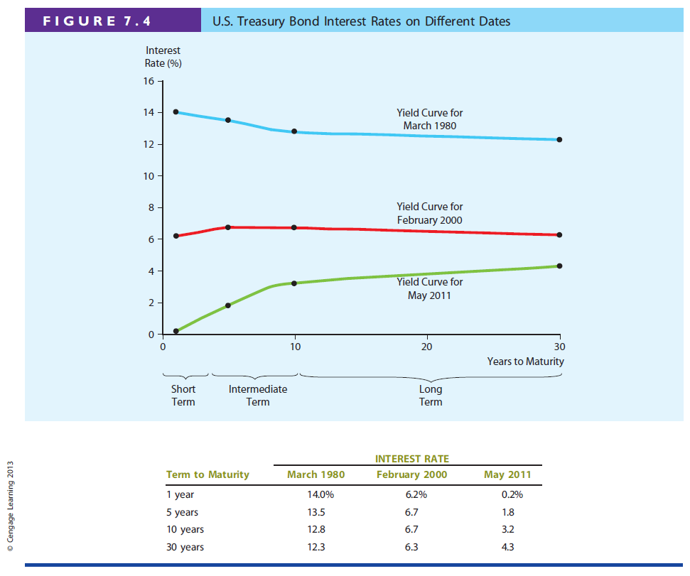
Yield Curve and the Term Structure of Interest Rates
- Term Structure – Relationship between interest rates (or yields) and maturities
Yield curve represents the relationship between yield- to- maturity and time-to-maturity across different bonds
- Yield Curve – A graph of the term structure
i/r (y-axis) vs yrs to maturity (x-axis)
- 3 Treasury yield curves are shown on the right

Constructing the Yield Curve (Treasury yield curve)
- r_{RF, t} = r* + IP_{t} + MRP_{t}
- Step 1: Find the average expected inflation rate over Years 1 to N
  - Formula

- E.g. assume inflation is expected to be 5% next year, 6% the next, and 8% thereafter

- These IPs must be earned to break even vs. inflation; these IPs would permit you to earn r* (before taxes)
- Step 2: Find the appropriate MRP
  - Formula (will be given): MRP_{t} = 0.1% (t – 1)
  - Using the given equation,

  - Equation is linear, MRP will increase as time to maturity increase
- Step 3: Adding the premiums to r*
  - r_{RF, t} = r* + IP_{t} + MRP_{t}
  - Assume r* = 3%,

Hypothetical Yield Curve
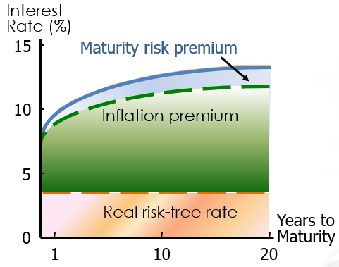
- Yield curve is often upward-sloping due to an increase in expected inflation and increasing MRP (Long term rates are above the short term rates due to MRP)

- Will the yield curve slope downwards?
  - Yes, when the IP falls, and when the fall is greater than the increase in MRP
    - r_{RF, t} = r* + IP_{t} + MRP_{t}

Foreshadows economic downturn (Decrease in inflation -> Decrease in long term rates)
Humped slope; i/r on intermediate term maturities > Short & long term maturities

Relationship between Treasury Yield Curve and Yield Curves for Corporate Issues
- Corporate yield curves are higher than that of treasury securities, though not necessarily parallel to the treasury curve
This is because of the addition of DRP and LP for corporate
R = r* + IP + DRP + LP + MRP
- As corporate bond rating decreases, the spread between the 2 curves widen
  - Corporate bond ratings indicate the likelihood of default (DRP RISES) by the borrower
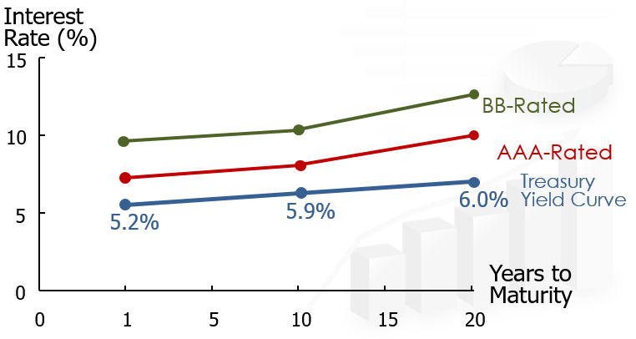

- Downward sloping yield curve of corporate bonds can only be due to the fact that inflation rates are expected to decrease. Still, the reason is that maturity risk premium, liquidity premium and default risk premium are all increasing with time-to-maturity
Macroeconomic Factors influencing I/R Level
- Federal reserve policy (Monetary Policy); Controlled by the central bank
During recession/economic downturn -> Stimulate economy by INCREASING money supply -> i/r FALLS
CONVERSELY, to reduce inflation -> DECREASE money supply -> INCREASE i/r
Initial effect of monetary easing = Short term rates FALL
Long term effect = INCREASE in expected future inflation -> Long term rates INCREASES
- Government budget deficit/surplus
*NEGATIVE r/s between bond price & i/r
Government spending > Tax revenue = Deficit
During a deficit -> INCREASED borrowing (Selling treasury bonds/printing $) -> INCREASED demand for funds -> INCREASE in i/r
***The LARGER the federal deficit, the HIGHER the i/r
- International factors; imports & exports
Foreign trade deficit = Imports > Exports (M>X) -> INCREASED borrowing from nations with export surpluses
***The LARGER the trade deficit, the HIGHER the tendency to borrow
- Level of business activity; INCREASED inflation = INCREASED i/r & Recession = DECREASED i/r
***Short term rates DECLINE MORE SHARPLY than long term rates
Long term rates reflect AVERAGE EXPECTED inflation rate
    - SHORT TERM RATES ARE MORE VOLATILE!
Lecture 4: Bonds and Their Valuation
What is a Bond?
- Instrument to borrow money
- A long-term debt instrument in which a borrower agrees to make payment of principal and interest, on specific dates, to the holders of the bond
- Zero coupon bond; Coupon bond
- Definitions:
  - Par value – face amount of a bond, which is paid at maturity
  - Maturity – date the bond must be repaid
  - Yield to maturity – nominal rate of return earned on a bond held until maturity
  - Coupon – amount paid by the issuer regularly
  - Coupon interest rate – stated interest rate paid by the issuer, multiply by par value to get dollar payment of interest
  - Coupon = Coupon interest rate x Par value
Zero Coupon Bond
- E.g. Company MNO (borrower) will pay the bearer (lender) of this bond certificate: $1000 (par value) on January 31, 2019 (maturity date)
- If I paid $900 for this bond, how much return would I earn? (Pay 900 and get 1000 back in 4 years)
Yield = Return = Interest Rate
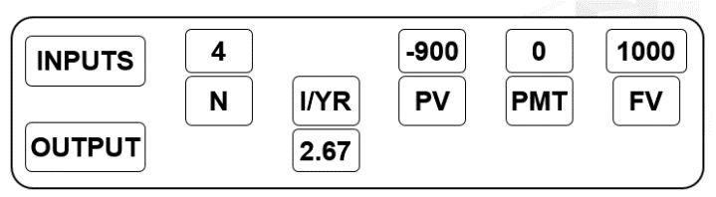
- Using the financial calculator, can find the returns (2.67%)

Use PV = FV/(1 + I)^N

Zero coupon bond ALWAYS trades at/below its par value!
Coupon Bond
- E.g. Company MNO will pay the bearer of this bond certificate: $1000 on January 31, 2019, and the following coupons ($60 per year from 2016)
Coupon price = Coupon i/r x Par value
- For this case, PMT = $60 instead of $0 since receive payment monthly
Bond Certificate
- Fixed and cannot be changed:
  - Par value
  - Coupon interest rate
  - Maturity date
  - Payment frequency
- Not fixed:
  - Price of bond
CF = Cash flows (coupon payments and payment of par value at maturity)
Regardless, CF are fixed, aka coupon value is the same no matter what value (PV) you put in. Hence, if pay high price, will get low return of % and if want high returns, should be willing to pay low price
  - Yield to maturity
Bond Valuation
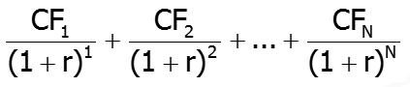
Financial Assets Valuation
- Value =
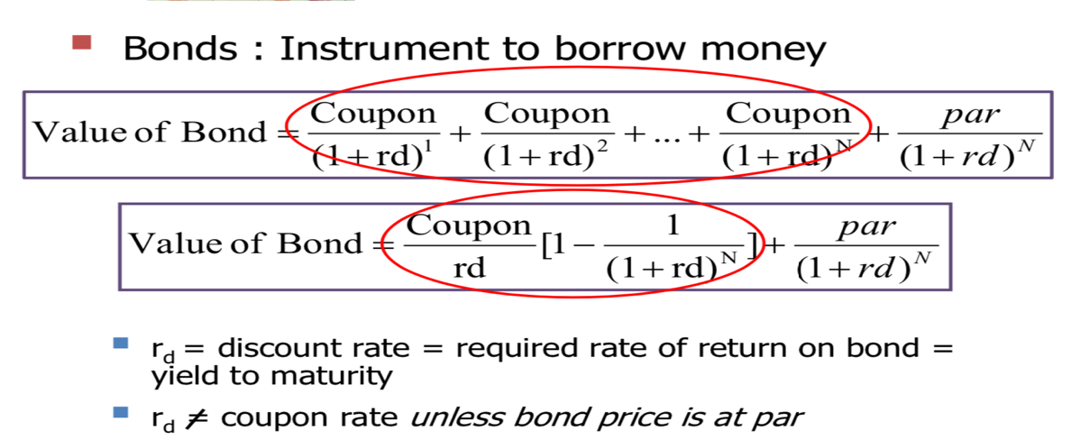
Formula is similar to PV = PMT/I (1 – 1/(1 + I)^N)
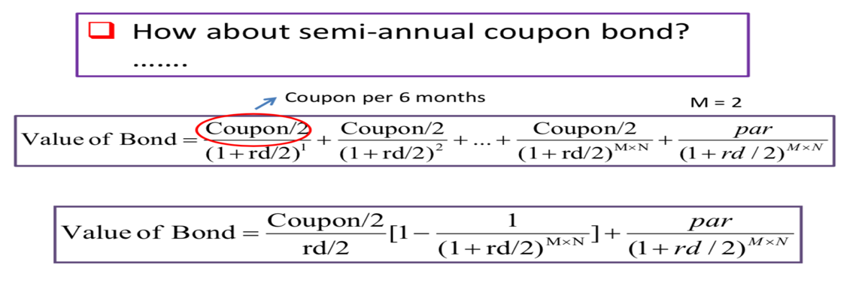
REMEMBER: Coupon/2 & Rd/2 & N x 2
Opportunity Cost of Debt Capital
- The discount rate (r) is the opportunity cost of debt capital, and is the rate that could be earned on alternative investments of equal risk
  - Discount rate = return = yield to maturity
- For annual bonds, discount rate is
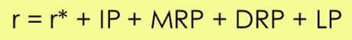

- Implications: 2 annual bonds with the same maturity and same risks must have the same r! -> Two bonds with same risk should have the same effective YTM. Their nominal YTMs may be different if the frequencies of their coupon payments are different.

Par, Discount and Premium Bond
- If yield (YTM) = coupon rate, then bond price = par value => par bond
- If yield (YTM) < coupon rate, then bond price > par value => premium bond
- Investors pay higher than par value because the coupon rate is higher than their required yield
- If yield (YTM) > coupon rate, then bond price < par value => discount bond
***No difference in return for an investor when comparing a discount bond and a premium bond, if the effective yield to maturity of the two bonds are the same and remain constant during the holding period.
Measuring Yield
- Use GC to enter the values, YTM = interest rate
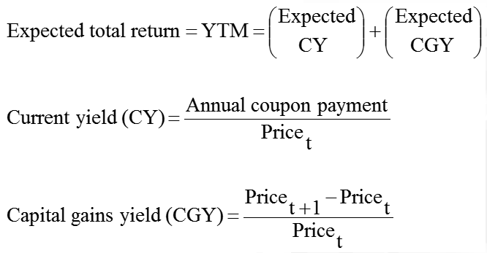
The Total Return Identity

If this value is negative, it means a capital loss

- Example: For a 10-year, 9% annual coupon bond that sells for $887, and has face value of $1000
- E(CY) = 90/887 = 10.15%
- To find E(CGY), have to find the bond price in the next year (N=10 and N=9)
  - First, find the interest rate of the 10th year ($887)
  - Using the interest rate, find the PV of the 9th year ($893.79)
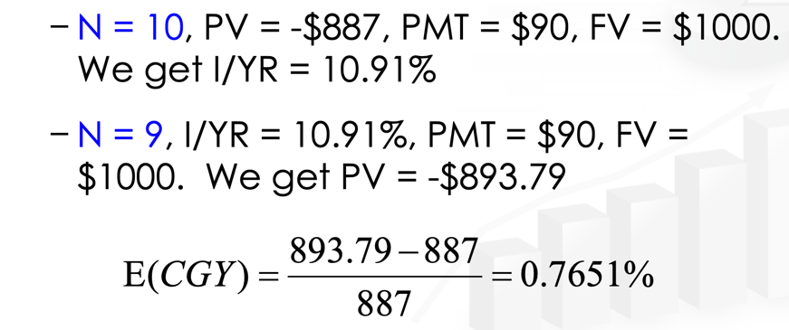
- E(CGY) = (893.79 – 887)/887 = 0.7651%
- Another faster method to find E(CGY) is to use the formula: YTM – E(CY) = E(CGY)

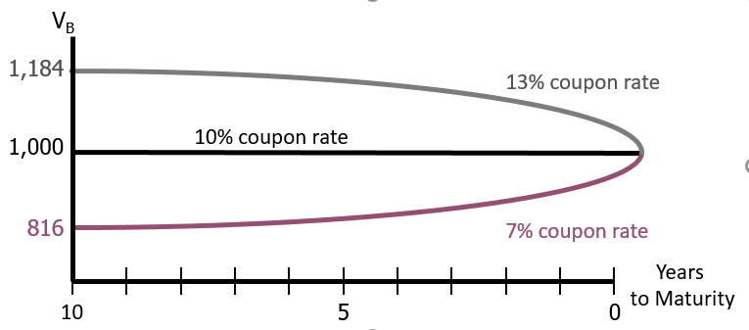
Changes in Bond Value over Time
If required rate of return remained at 10%:
(Premium) Value will decrease overtime until 10% which signifies a capital loss, but its compensated by the high current yield
Neither is favourable over the other, unless there are taxes – capital gains may be taxed differently from coupon payments (esp in US)

(Par)
(Premium)
(Discount)
- If yield (YTM) = coupon rate, then bond price = par value => par bond
- If yield (YTM) < coupon rate, then bond price > par value => premium bond
- Investors pay higher than par value because the coupon rate is higher than their required yield
If yield (YTM) > coupon rate, then bond price < par value => discount bond
What would happen to the value of par, premium & discount bonds if required rate of return Rd, remained at 10%?
Ans: At maturity, value of ANY bond = par value.
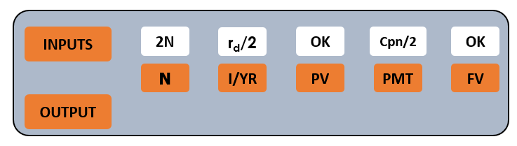
Semi-Annual Bonds
- Multiply years by 2: Number of periods = 2N
- Divide nominal rate by 2: Periodic rate (I/YR) = r_{d}/2
- Divide annual coupon by 2: PMT = Annual coupon/2

Risks of a Bond
- Investment Risk: Concern that increasing discount rate, Rd, causes bond value to decrease
***Bonds with longer maturity; (More sensitive to changes in i/r) have higher interest rates risk
  - Interest Rate Risk (Price Risk)
  - Reinvestment Risk; Concern that discount rate, Rd, decreases & future cashflows will have to be reinvested at lower rates, resulting in lower income
- Default Risk
Interest Rate Risk
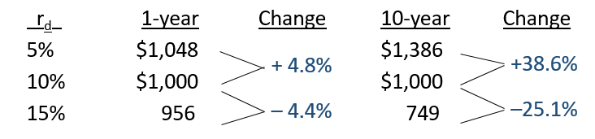
- The concern that rising r_{d} will cause the value of a bond to fall

- All else being equal, bonds with longer maturity have higher interest rate risk
  - Long maturity bonds are more sensitive to interest rate changes
Reinvestment Risk
- The concern that r_{d} will fall, and future CFs will have to be reinvested at lower rates, hence reducing income
- Eg. $500 000, can invest in a 10-year bond or a series of ten 1-year bonds, both currently yield 10%
  - If choose 1-year bond, after year 1, will receive $50 000 in income and have $500 000 to reinvest. But if rates fall to 3% (3% of $500,000), annual income will fall to $15 000
  - If choose 10-year, can lock in a 10% interest rate and earn $50 000 in annual income
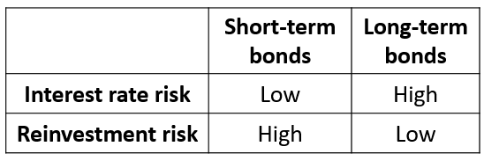
- Conclusion: Nothing is riskless
REMEMBER:
1.Long maturity bonds have higher i/r risk
2.Long Term bonds have less reinvestment risk

Default Risk
- If an issuer defaults, investors receive less than then the promised return
- Influenced by the issuer’s financial strength and the terms of the bond contract
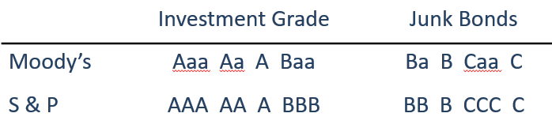
- Bond ratings reflect the probability of a bond issue going into default

Relationship btw Market interest rate and bond price
- Fall in market int rate = fixed int and principal payments become less attractive = bond price fall
  - Eg if bond coupon interest rate is 9%, and market interest rate increase to 10%, people will want to put their money in bank since will receive more $.
  - In order for interest rate of bond to increase to 10% or more, bond price have to fall.
Sinking Fund
- Sinking funds are provisions included in bond indentures (legal contract) that require companies to retire bonds on a scheduled basis prior to their final maturity
- Many indentures allow the company to acquire bonds for sinking fund purposes by either
  - (1) purchasing bonds on the open market at the going market price or
  - (2) selecting the bonds to be called by a lottery administered by the trustee, in which case the price paid is the bond's face value.

Lecture 5: Risk and Rate of Return
Most investors are risk averse; Dislike risk & require HIGHER rate of return to encourage them to hold riskier securities
NOTE: Does not mean that they always choose the lowest risk investments!
- Investment Returns
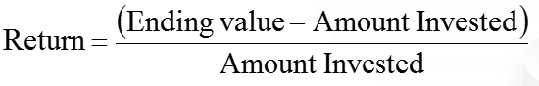

- Investment Risk
  - Related to the probability of earning a return that is different from expected
- Total/Stand-alone risk
- Portfolio risk
***The greater the chance of earning a return different from expected = RISKIER investment
Individual Stock – Stand-alone Risk/Total Risk
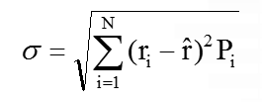
Standard Deviation

- Used to measure whether returns are likely to be close to the expected returns
- Higher SD = More risk
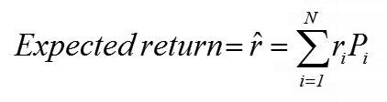
Expected Return for Each Investment
Can also be used for required return ONLY IF market is in equilibrium since expected = required

- R_{i} – Expected return at i state of the economy (recession, boom etc.)
- Pi – Probability that that state of economy will occur
- R hat – Expected return of the stock
Coefficient of Variation (CV)

- Shows the risk per unit of return
- Useful when comparing investments with different expected returns
- Highest CV = Highest risk (Increase in stand-alone risk)
Stocks in a Portfolio – Portfolio Risk
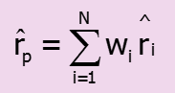
Method 1:
- Find the weighted average of the returns
- W_{i} – weightage of stocks (eg. Hold 40% of A, 60% of B)
- ^r_{i} – expected returns x probability
Method 2:
- Find the total returns of both stock in each state of economy according to the weightage
- Add up all the (returns x probability of state of economy)
Standard Deviation
- Same as individual stock

Portfolio’s Risk Measures
- Some risks are diversified away (SD tend to be much lower than the SD of either stock)
- However, the benefits of combining stocks depend on the correlation coefficient between the stocks
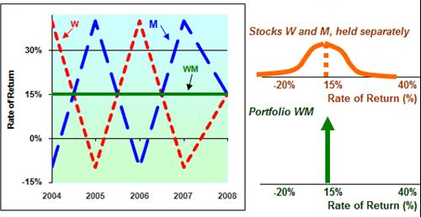
  - Perfectly negatively correlated (p = -1.0) – least risk
  - Riskless portfolio as returns move COUNTER CYCLICALLY; ALL risks diversified away!

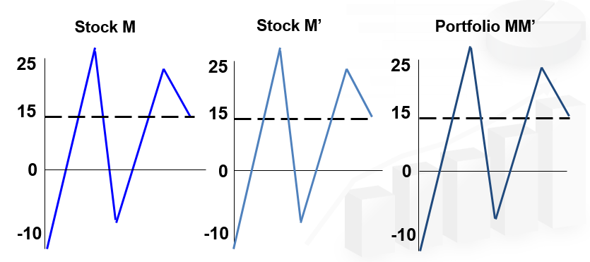
  - Perfectly positively correlated (p = 1.0)
  - Stocks & portfolio have the same returns at each point in time; NO risk diversified away!

  - Partial correlation (p = +0.35)
  - Risk reduced but not completely; SOME risk diversified away
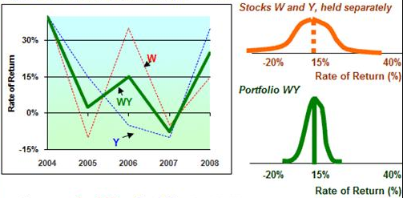

- Diversification benefits exists as long as stocks are not perfectly positively correlated
- Eventually the diversification benefits of adding more stocks dissipates, and for large stock portfolios, σp tends to converge to 20% ; Combining stocks with portfolios reduces risk, portfolio’s risk DECLINES at a DECREASING RATE as stocks are added
Breakdown of Sources of Risk
- Stand-alone risk
  - Diversifiable risk (Companies specific, unsystematic)– a portion of stand-alone risk can be eliminated through proper diversification; Stocks you add to portfolio shouldn’t have perfectly positive correlation
    - Caused by idiosyncratic events (Eg. Workers strike)
    - No compensation for holding unnecessary, diversifiable risk
  - Market risk (Systematic, undiversifiable)– a portion of stand-alone risk CANNOT be eliminated by diversification, measured by BETA, caused by macro factors (Eg. Recession, inflation)
*Market portfolio do not have diversifiable risk! Only for individual stocks
-> Market portfolio consists of stocks with different correlation coefficients. When combined, all diversifiable risks are diversified away & only MARKET RISK IS LEFT.
*Systematic (Market) risk will not be diversified away in a portfolio when you randomly increase the number of stocks.
Capital Asset Pricing Model (CAPM)
- Model linking risk and required returns
- Suggests that a stock’s required return = risk free + risk premium (Market risk premium) that reflects the stock’s risk after diversification
- r_{i} = r_{RF} + (r_{M} – r_{RF})b_{i}
  - Market Risk Premium – Additional return to compensate investors for assuming an average amount of risk
  - (rM-rRF) size depends on; Perceived risk of the stock market & investors degree of risk aversion Eg. Changes in exchange rates, critical instability & outlook of the economy
***Increase in degree of risk aversion = Increase in Market Risk Premium
Beta
- Measures a stock’s market risk, shows stock’s volatility relative to the market; How a stock is expected to move relative to the market in the future
- Change in return over change in market; Changes in market portfolio are due to market wide events
- Interpreting Beta
  - 1.0 – security move together with the market (Market beta =1.0); Security as risky as average stock
  - > 1.0 – more volatile; Security is risker than average stock
  - < 1.0 – less volatile; Security is less risky than average stock
Diversified stocks qns are usually linked to beta
  - Stock can have negative beta!
  - If its fixed returns, beta = 0, treasury (no risk) also beta =0
- Calculating beta for portfolio
  - Beta = b_{a}w_{a} + b_{b}w_{b}
- Calculating betas; Run regression of the security’s past returns against the past returns of the market (Slope of the regression line = Beta coefficient) Ri (y-axis) vs Rm graph (x-axis)
***BETA VALUE CAN BE NEGATIVE!; Investment moves in the opposite direction from the stock market -> Investment with negative beta offers a hedge against serious market downturns
***We cannot tell the relative level of stand-alone risk simply by looking at the beta of the two stock
Security Market Line (SML); Depicts the relationship between beta and the required rates of return on individual stocks
- r_{i} = r_{RF} + (r_{M} – r_{RF})b_{i}
- If slope is constant means the risk premium is constant (gradient is the same)
- Factors that change the SML
  - Expect higher inflation = parallel shift of SML (r_{RF} increased)
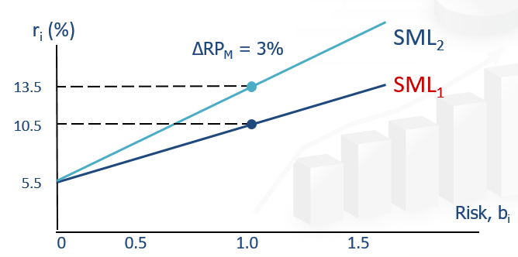
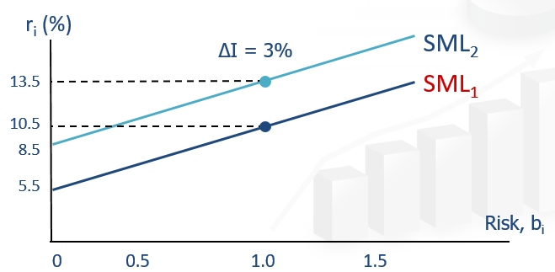
  - Increase risk adversion = gradient change since r_{M} – r_{RF} will change

Expected v Required v Realised
- Expected: Returns that an investor expects to get (only buy when expected > required)
  - Actual stock price
- Required: Returns and investor requires given the riskiness of stock
  - Usually Beta, CAPM/SML
- Realised: Returns you actually get
  - If price drop, returns will increase, why?
  - Because returns are for the next buyer
  - Can be negative
- Expected & required are forward looking; realised is historical

Lecture 6: Stocks
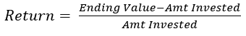
- Returns: Appreciation of stock value; Dividends
- Intrinsic Value (): Estimate of the actual value of stock
  - Stock price < Intrinsic value = undervalued
  - Stock price > Intrinsic value = overvalued
  - Stock price = Intrinsic value = Equilibrium
*Intrinsic values are used to determine which stocks are attractive to buy/sell
Estimating Intrinsic Value
Discounted Dividend Model (Constant Growth); Value of the stock is the present value of the future dividends expected to be generated by the stock
- Dividends grow forever at constant rate, g
Step 1: Calculate required rate of return (r_{s}) using SML
Step 2: Find the expected D₁
Step 3: Calculate intrinsic using constant growth model
- D₁ = D₀ (1+g)¹
- D_{t} = D_{t-1} (1+g) = D₀ (1+g)^{t}
- Formula converges to
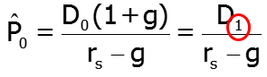

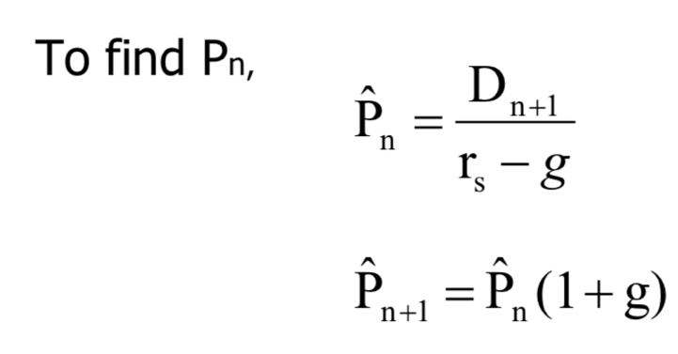
Constant growth stock can only be used when
- r_{s} > g!
- g = constant. 
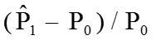
- E(DY) = D₁/P₀
- E(CGY) = g =
E(total returns) = E(DY) + E(CGY); Total return for a bond investment = Current yield + Capital gains yield.
*E(DY) and E(CGY) is constant throughout for constant growth stock; E(CGY) = g because constant
Constant-growth stocks; Expected constant growth rates = Expected capital gains yields
***Dividend yield can never be negative as both dividend and price cannot be negative
- Expected future growth rate (g)
Payout = Dividends/Net income
Return on Equity = Net income/total common equity
  - g = (1 – Payout; Dividends/Net income) (ROE; Net income/Total common equity)
  - g = (Retention ratio) (ROE)
Discounted Dividend Model (Non-constant Growth)
- Question type: At xx% for 2 years then constant at yy% all the way
- Use PV method – calculate backwards
- (Eg. Dividend grow at 30% for 3 years before constant growth of 6%
- Step 1: Find the dividends given every year from D₀ to D₄; D1=2.0 x 1.30, D2=2.0 x (1.30)^2,.. given that dividend = $2
- Step 2: Find the intrinsic value at P₃ = D₄ / (r_{s} – g); rs=0.06
- Step 3: Sub into the equation, will become
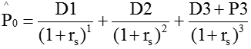

- Do not add D₀ because those are dividends that you didn’t get
- E(DY) same, E(CGY) = r_{s} – E(DY)
Multiples of Comparable Firms
- P/E; Stock price divided by earnings per share
***P/E ratio is a tool you can use to estimate the fair value of the stock market -> Used for comparison for companies in the same industry thus P/E ratio can be used as a metric to compare stocks

- P/CF
- P/Sales
- Based on comparable firms, estimate P/E, then multiply by expected earnings to get an estimate of stock price
Preferred Stocks; Preferred stockholders receive a fixed dividend that must be paid before dividends are paid to common stockholders
2 types of equity securities; Common stock & preferred stock
- A hybrid security – falls in between bonds and stocks in terms of risk
- Stockholders receives a fixed dividend, but companies may omit payment if they unable to pay
  - Unlike bonds – dividend (coupon) MUST be paid or can be sued
- V_{p} = D/r_{p}
  - r_{p} = expected returns
  - V_{p} = selling price (value)
Market Equilibrium; Stock prices are stable & there is no general tendency for people to buy versus to sell
- In equilibrium, stock prices are stable
- Intrinsic = actual value
- Expected returns = required returns
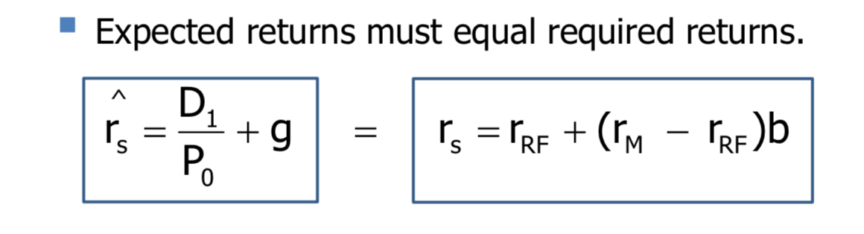
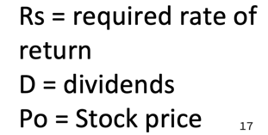
How is Equilibrium Established?
- If price below intrinsic value current price too low, offers a bargain
- Buy orders > sell orders
- Price will be bid up until expected returns = required returns
How are Equilibrium Values Determined?
- Based on market’s estimate of intrinsic value and market’s required rate of return, which are both dependent on the attitudes of the marginal investor
Stock Market Efficiency
- Efficient market is a market in which prices are close to intrinsic value and stocks seems to be in equilibrium
NOTE: Does not require market price = intrinsic value at every point of time!
Deviation between the market price & intrinsic value is random!
***When the market is efficient, investors cannot consistently earn abnormal returns (Returns>Ave. investors)
- Events are reflected in stock prices immediately (random events)
- Small companies are usually inefficient since not much contact with investors + not many analysts; opposite for large companies

Lecture 7: The Cost of Capital
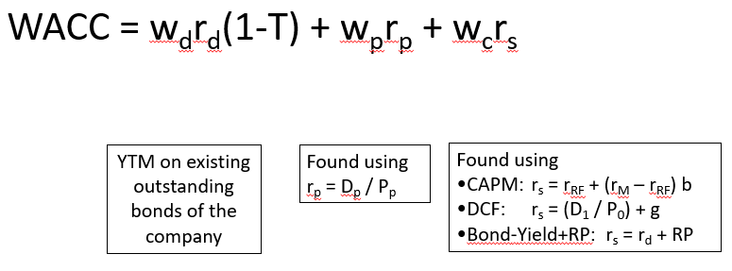

Capital Budgeting
- Analysis of potential projects (eg. investments in tangible and intangible assets; marketing)
Reminder:
Goal is to maximise shareholder’s wealth!
- LT decisions involve large expenditures – important to firm’s future
- Hence, need procedures to analyse and select LT investments
Steps
- Estimate cash flows (CF) – Initial investments + subsequent cash I/O flows (Lecture 9)
- Assess the riskiness of CFs and determine the appropriate risk-adjusted cost of capital for discounting CFs – Finding the discount rate
- Find NPV and/or IRR (MIRR) (Lecture 8)
Weighted Average Cost of Capital (WACC)
Sources of LT Capital that Firms use
- D = Long-term debt (+ any ST if used on regular basis)
- P = Preferred stock
- C = Common Equity
  - Retained earnings
  - New common stock
Capital Structure
- Mix of debt, preferred stock and equity used to finance the firm’s assets
Equation
Basic Concepts
- Use target capital structure weights (w) instead of actual financing of project
  - Desired optimal mix of equity and debt financing that most firms attempt to maintain in the LT
  - Eg. Want to use 100% of debt to finance, w_{d} ≠ 100% but based on TCS
- Use market value weights not book value weights
  - Market value reflects the actual amount of financing when sell stocks/bonds
- Use marginal cost not historical cost (irrelevant)
  - WACC is calculated at a point in time, and it reflects the marginal cost of raising an additional dollar of capital today
    - WACC is used in decisions to raise new capital, so should focus on cost of new capital
- Use after-tax capital cost
  - Shareholders focus on after-tax CFs, hence should focus on after-tax CC
  - Only r_{d} needs adjustment because interest is tax deductible (1 – T)
ONLY interest payments are tax deductible, dividend payments are NOT!
Component Cost of…

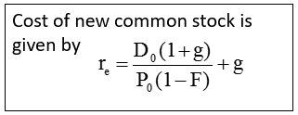

- w – firm’s capital structure weightage (should add up to 100%)
- r – cost of each component
- T – tax rate
- Cost of Debt
  - r_{d} (YTM on current outstanding bonds) is the marginal cost of debt capital – cost of raising an additional $ of debt today
    - Coupon rate is historical cost
  - YTM is a good estimate since it reflects the current market condition
  - Interest is tax deductible, so need to adjust r_{d}
- Preferred Stock
  - r_{p} is the marginal cost of preferred stock – the return investors require
  - Preferred dividends are not tax deductible
- Common Equity
  - r_{s} – retained earnings
    - Usually will use r_{s} in the calculation of WACC since a company will usually use retained earnings first before issuing new stock
  - r_{e} – new common stock
- Why is there a cost for retained earnings?
  - Earnings can be retained and reinvested or paid out as dividends
  - Investors could buy other securities, earn a return
  - If earnings are retained, there is an opportunity cost (return that stockholders could earn on alternative investments of equal risk – can buy similar stocks and earn r_{s})
3 Ways to Determine the Cost of Common Equity using Retained Earnings r_{s}
- CAPM
- DCF: r_{s} = (D₁/P₀) + g
A reasonable estimate is to add all 3 then find the average
  - Can still be applied even if growth is not constant because they are expected to attain constant at some point
- Own-Bond-Yield-Plus-Risk-Premium: r_{s} = r_{d} + RP
  - RP is different from the one in CAPM

Adjusting for Flotation Costs
- When company issue new common stock, they have to pay flotation costs to the underwriters (eg. investment bankers)
- This is why the cost of new stock is higher than retained earnings
- 2 methods to account for flotation costs:
  - Add flotation costs to the initial project costs
  - Adjust the cost of capital
- DCF method will be adjusted slightly to take into account the flotation costs

Factors Influencing a Company’s Composite WACC
- Market conditions
- Firm’s capital structure and dividend policy
  - If distribute out most earnings as dividends, firm will have little internal cash to fund their investment project
  - They will issue new common stock to raise funds
  - r_{s} will become r_{e} in the WACC
- Firm’s investment policy – Riskier projects generally have a higher WACC
Hurdle Rate
- Projects should be accepted if and only if their estimated returns > cost of capital
  - Cost of capital is the hurdle rate
Risk and the Cost of Capital

Should the Company use the Composite WACC as the Hurdle Rate for its Projects?
- NO
- The composite WACC reflects the risk of an average project undertaken by the firm – only represents the “hurdle rate” for a typical project with similar risk as the firm as a whole
- Different projects have different risks
- The project’s WACC should be adjusted to reflect the project’s risk
Adjusting for Risk

- Composite WACC is 10%
- WACC for L and H is different!
- Should use their respective WACC as hurdle rate
  - Eg. Project L will be taken because the WACC of 9% is higher than the hurdle rate of 7%

Lecture 8: Capital Budgeting
Steps to Capital Budgeting
- Estimate CFs – initial investments & subsequent cash inflow/outflow
- Assess riskiness of CFs and determine appropriate risk-adjusted cost of capital for discounting CFs
- Find NPV and/or IRR

Project L: Long Term
(CFs only come towards the end of the project – 60,80 etc)
Project S: Short Term

Types of Cash Flow Streams – Normal and Non-normal
- Normal Cash Flow Streams – 1 change of sign
- Non-normal Cash Flow Streams – 2 or more changes of signs
Types of Projects – Independent vs Mutually Exclusive
- Independent: If CFs of 1 project is unaffected by the acceptance of the other – accept both
- Mutually Exclusive: If one is accepted, the other one will have to be rejected
Capital Budgeting Decision Criteria
Payback/Discounted Payback
- Payback period: The number of years required to recover a project’s cost
- Calculated by adding project’s cash inflows to its cost until the cumulative cash flow turns positive
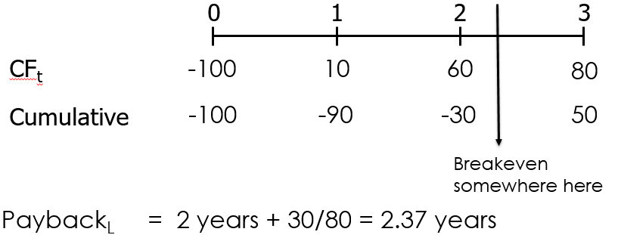
- Example:
Mutually Exclusive:
Choose the one with shorter payback

Independent:
Payback within 3 years

- Weaknesses
  - Arbitrary benchmark (eg. 3 years for independent) – this is subjective
  - Ignores time value of money
  - Ignores CFs after the payback period – even if the end profit is much higher
- Strengths
  - Easy to calculate and understand
  - Provides an indication of a project’s risk and liquidity
- Discounted Payback Period (to take into account TVM)
  - Use discounted CFs rather than raw CFs
  - Calculate the PV first, then calculate the cumulative

Net Present Value (NPV)
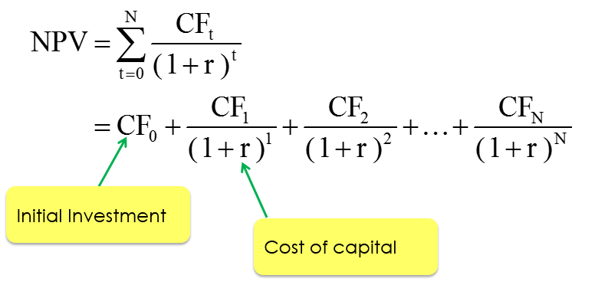
- Sum of the PVs of all cash inflows and outflows of a project

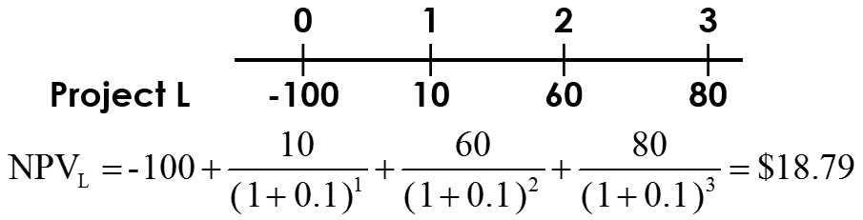
- Example

- Rationale for NPV Method
  - NPV = PV of inflows – PV of costs = net gain in wealth
  - NPV indicates how much shareholders’ wealth will increase if project is taken up
  - Independent: Accept both as long as NPV>0
  - Mutually Exclusive: Accept the project with highest positive NPV

- Drawing NPV Profiles – Graphical representation of project NPVs at different costs of capital
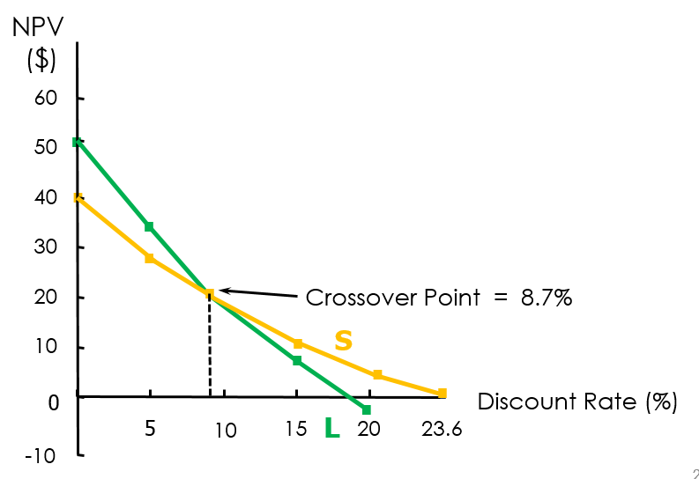
Have different slopes because there’s higher risk for LT than ST
Choice of project differs depending on whether the discount rate is higher/lower than the crossover point

- Calculating the Crossover Point
  - Equate the 2 IRR equations
  - Solve by simultaneous
  - Get the crossover point

Internal Rate of Return (IRR) – MIRR
- IRR is the discount rate that forces NPV =0
(X-intercept on the NPV Profile Graph)
- IRR is the expected annual rate of return that the firm will earn
- Example
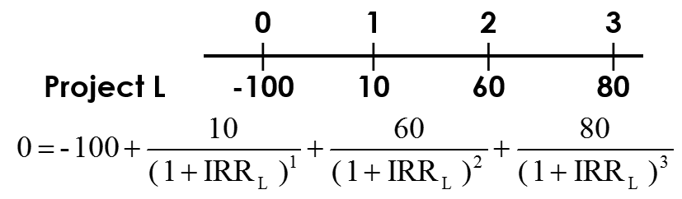

- If IRR > Cost of Capital, project’s return exceeds its cost and there is some return left over to boost stockholder’s returns
- Independent: Accept both if IRR > Cost of Capital
- Mutually Exclusive: Accept higher IRR
Comparing NPV and IRR
- If independent, either method will lead to the same decision
- If mutually exclusive, and
  - Discount rate > crossover rate – same decision
  - Discount rate < crossover rate – different decisions
- This is due to the timing differences in CFs and the difference in scale
  - Differences = different amount to reinvest at various years depending on which mutually exclusive project they accept
  - Rate at which intermediate CFs are reinvested is critical!
NPV is Superior to IRR
- Reinvestment rate assumptions
  - IRR assumes intermediate CFs are reinvested at IRR
  - NPV assumes intermediate CFs are reinvested at cost of capital
  - Assuming reinvestment at cost of capital is more realistic, NPV better
- Projects with different scales
  - Assume choosing between 2 projects
  - According to NPV, choose L
Of the 2, will choose NPV since much more profit!
  - According to IRR, choose S
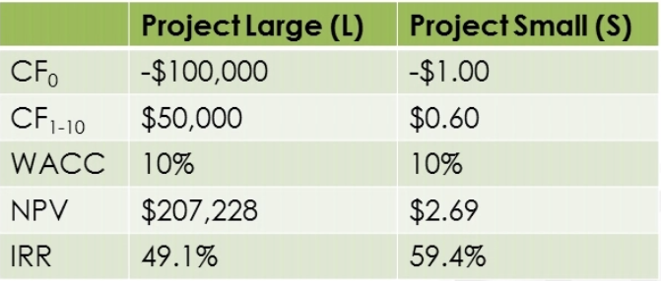

Modified IRR
- Modify IRR such that immediate cash flows are reinvested at the cost of capital
- Assumes reinvestment rate* as the cost of capital
- MIRR is the discount rate that cause the PV of a project’s terminal value (TV) to equal the PV of costs
  - TV is found by compounding inflows at cost of capital
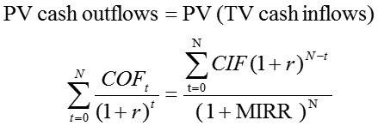

- Example
  - Step 1: Calculate the FV of all cash flows
  - Step 2: Sum all all FV = TV = 158.1
  - Step 3: Discount the FV at MIRR to t=0
  - Step 4: Equate the value from step 3 to the initial cost ($100)
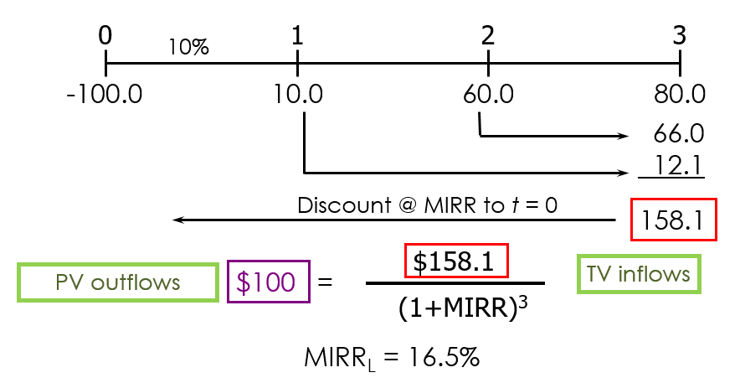
  - Step 5: Calculate MIRR from the equation

Why use MIRR over IRR?
- Managers like rate of return comparisons, MIRR is better for this than IRR (but managers still choose IRR)
  - MIRR avoids the multiple IRRs problem
- NPV superior to MIRR superior to IRR
- MIRR has the same problem for comparing projects with different scales

Multiple IRRs
- For non-normal cash flows, IRR may be a value or “error”
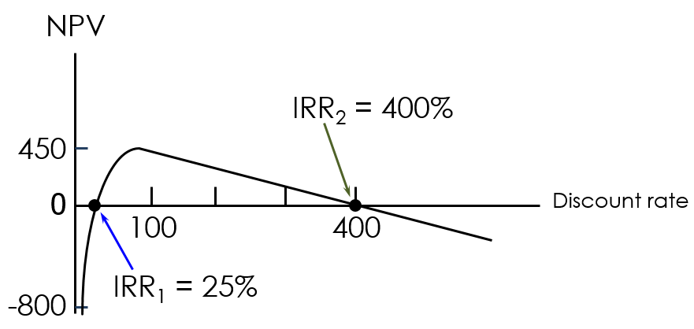
- Because of shape of graph for non-normal!

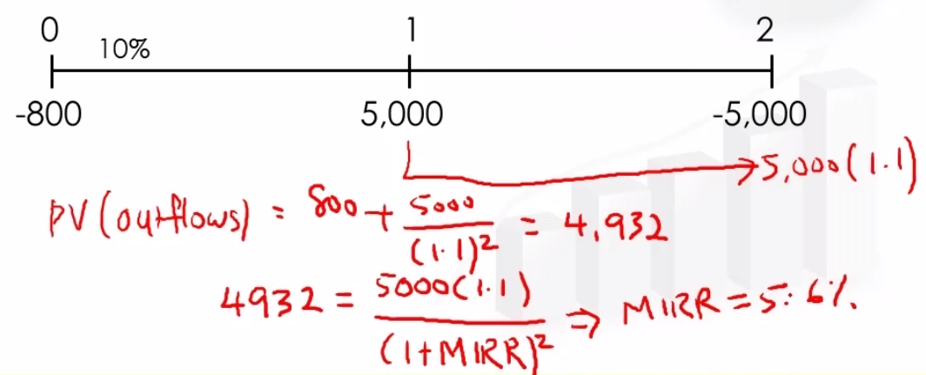
- Hence, for non-normal, use MIRR method

- This project will not be accepted because NPV < 0 and MIRR of 5.6% < 10%

*Difference between reinvestment rate of MIRR and IRR
- Reinvestment rate for IRR is IRR
- Reinvestment rate for MIRR is WACC
  - Makes more sense to reinvest at, at least the cost

Lecture E: Financing for SMEs
Sources of Funding
- Internal funds – owner’s savings, company’s profits
- Overdrafts and bank ST loans – to fund working capital
  - Overdraft is a facility to withdraw certain limited amount of money (more than what you have in your account such that your account is not deficit)
- Bank LT loans – to finance asset purchasing, investments
- Leasing and hire purchase management – to purchase capital equipment (PPE)
- Stock market equity and corporate bond issues – to finance large and LT projects
- Venture capital or private equity
  - Venture capital is the financial capital provided to start-up companies
  - Private equity is financial capital from firms specializing in investing and acquiring equity ownership
- Asset-based funding such as factoring and invoice discounting
  - Factoring is where a business sells its accounts receivable to a third party at a discount
- Trade Credit – the delay in paying for purchases of goods and services
Major Sources
- Informally, earnings internally generated + trade credit are the main source
- Formally, commercial banks are the main formal suppliers of external finance
- While public companies can issue bond/stock, private companies tend to be highly reliant on banks or private equity financiers
Government Assistance
- Tax incentive such as Productivity and Innovation Credit (PIC)
- Grants such as Capability Development Grant (CDG)
- Loans such as government-backed loans for working capital, trade financing through participating financial institutions
  - Local Enterprise Finance Scheme (LEFS)
  - Loan Insurance Scheme (LIS)

Lecture 9: Cash Flow Estimation, Risk Analysis and Optimal Capital Budget
Cash Flow vs Accounting Income
- Net income and operating income etc. are accounting numbers
- When evaluating projects, should look at the cash flows rather than accounting numbers
- Relevant Cash Flow: Incremental cash flows that will occur if and only the project is accepted
- Net Operating Working Capital (NOWC)
  - = Current Assets – (Accrued Wages and Taxes + Accounts Payable)
  - = Current Assets – (Current Liabilities – Notes Payable)
- Free Cash Flow (FCF)
  - Cash flows available to shareholder and debtholders less the need for re-investment to operate and produce future CFs

- EBITDA = Earnings Before Interest, Tax, Depreciation, Amortization
- EBIT = Operating income = Sales – Operating Costs – Depreciation (then add back later)
Interest expense is deducted before tax is subtracted
- Depreciation = Non-cash expenses that lowers the EBIT but does not decrease the amount of cash that the company have to pay to investors
- Capital Expenditures = investments in fixed assets
- Change in NOWC = investments in current assets/current operations

Example: The Lemon Juice Project (Expansion Project)
- The project is expected to last for 4 years
- Equipment will cost $200,000 plus an additional $40,000 for shipping and installation
  - The equipment will be depreciated under the MACRS system
  - At the end of 4 years, salvage value is $25,000
- The changes to net operating working capital (NOWC) include the following:
  - Inventories will increase by $25,000
  - Accounts payable will rise by $5,000
- New sales of 100,000 bottles of lemon juice per year @ $2 per bottle
- Total operating expenses (excluding depreciation) are expected to be 60% of dollar sales
- Tax rate is 40%, Cost of capital is 10%

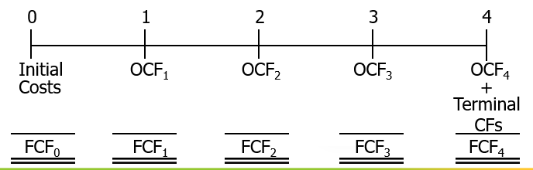
Determining Cash Flows [NOWC, ChangeNOWC]
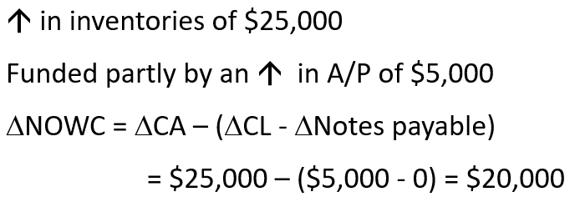
- Find the change in NOWC

- Combine the change in NOWC with Capital Expenditure
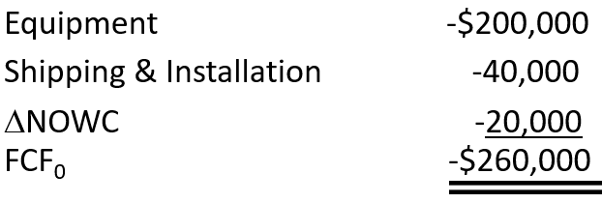

Determining Annual Depreciation Expense
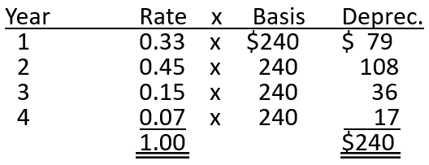

*Do not need to minus off salvage value!
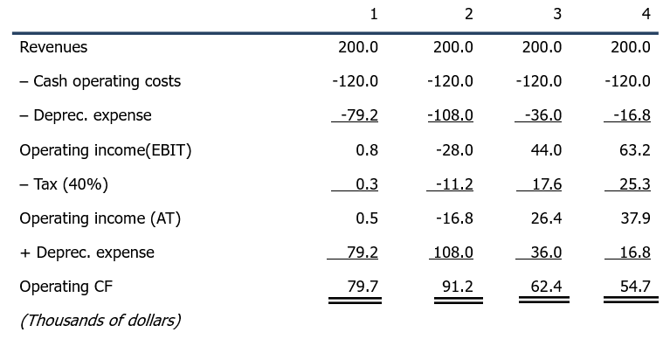
Annual Operating Cash Flows [EBIT(1-T) + Depreciation]

Terminal Cash Flow
- Find the after-tax salvage value
  - Machines sold for $25,000
  - Taxes = 40% of difference between salvage value and remaining book value
    - T x (Salvage Value – Remaining Book Value)
  - After-tax salvage value = 25,000 – 10,000 = 15,000
There’s a recovery because you have 1) Sold off all inventory and 2) Paid off accounts payable associated with the project
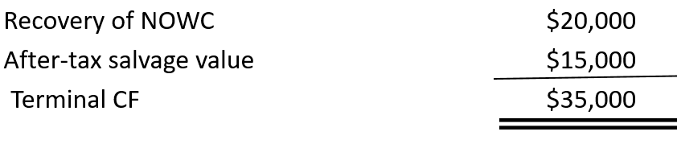
- Combining with NOWC

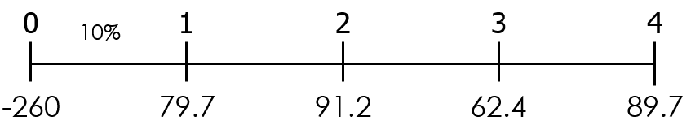
Proposed Project’s Cash Flow Timeline

Uncertainties in Estimation
- Most inputs are estimates
- To understand how uncertainties, affect our decision to accept/reject a project, perform the below procedures (used to understand/measure the standalone risk of project)
Sensitivity Analysis
- Examines how sensitive NPV is to changes in each input variable
- All other variables are held constant at base value
Scenario Analysis
- Possible alternative scenarios with different input values are proposed
- Probabilities are assigned to each scenario Project’s expected NPV and standard deviation/CV of NPV
Monte Carlo Simulation
- Simulation techniques where the NPV for many scenarios are calculated Project’s expected NPV and standard deviation (CV) of NPV
Calculation of Cash Flows
- Ignore: Interest charges; sunk costs
  - Interest charges: already included in the NPV equation – already accounted for)
- Account for: Opportunity costs, externalities

Other Types of Project Categories
Replacement Projects (old Assets may not be efficient anymore)
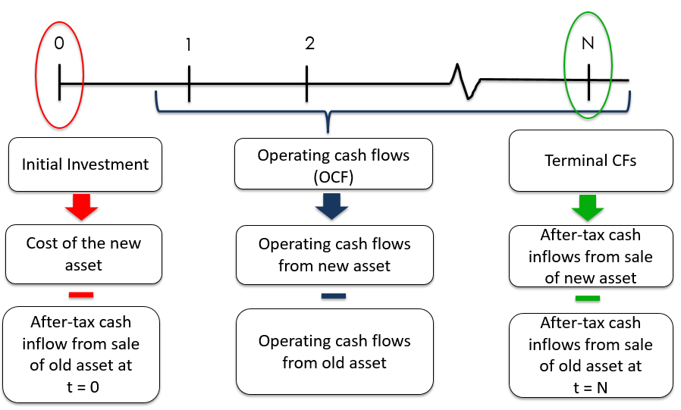
Timeline:

Leasing
(Leasing vs. Borrow-and-Buy)
- How to acquire the asset?
  - Option 1: Lease the asset
  - Option 2: Borrow funds to buy the asset (Borrow-and-Buy)
  - Option 3: Use available cash on hand to buy asset
  - Option 4: Raise equity to buy asset
- Leasing is the most similar to debt financing, so we compare leasing to option 2 regardless of how the asset is being financed
  - Calculate NPV under leasing compare against NPV of borrow-and-buy when deciding whether to buy or lease
  - Financing methods does not matter here

- Borrow-and-Buy
  - New machine costs $1,200,000.
  - Can be financed with a 10% loan to be amortised over four years with end-of-year payments
  - 3-year MACRS class life; 4-year economic life
  - Maintenance of $25,000/year, payable at beginning of each year
  - Salvage value in Year 4 = $125,000

- Lease
  - 4-year lease includes maintenance
  - Lease payment is $340,000/year, payable at beginning of each year
  - Tax rate = 40%
- In a lease analysis, at what discount rate should CFs be discounted?
  - CFs in leasing/borrow-and-buy are certain (since terms stated in contract)
    - Use cost of debt to discount CF
  - CFs in lease analysis are evaluated on an after-tax basis, hence should use after-tax cost
    - Should discount at 6% = 10% (1 – 0.4)
Cost of Owning Analysis
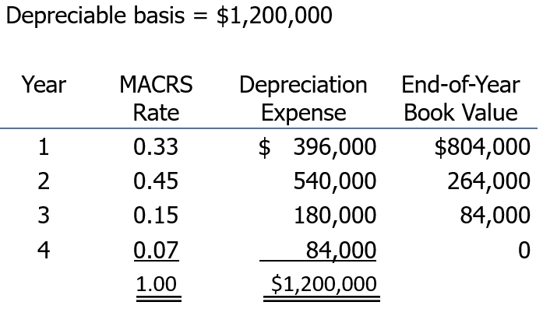

Depreciation expense is a non-cash expense but it reduces the taxes that firm pays (cash inflow):
Dep tax savings = Dep expense*T

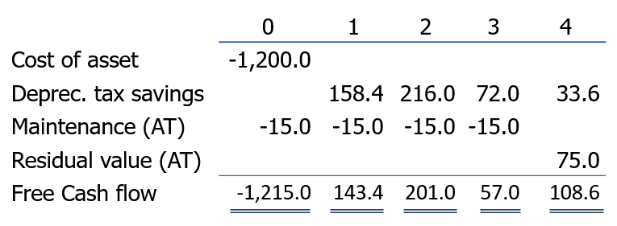
Maintenance expense is a cash expense and it reduces taxes that firm pays: Maintenance (AT):
- Main expense + Main expense*T
- Depreciation is a tax-deductible expense, so it produces a tax savings of T(Depreciation).
E.g. Year 1 = 0.4($396) = $158.4
- Each maintenance payment of $25 is tax deductible so the after-tax cost of the maintenance payment is (1 – 0.4)($25) = $15
- The ending book value is $0 so the full $125 salvage value is taxed.
- Therefore, the after-tax salvage value = 125-0.4(125-0) = $75
- PV discounted at 6% = $766.948

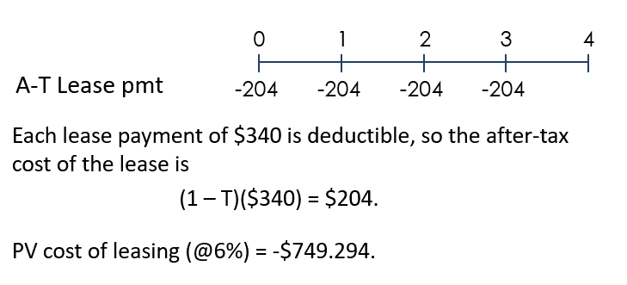
Cost of Leasing Analysis

Net Advantage of Leasing
- NAL = PV of Cost of Owning – PV of Cost of Leasing
= 766.948 – 749.294
= 17.654 (dollars in thousands)
- Since cost of owning outweighs the cost of leasing, the firm should lease (choose option with least cost)
The Optimal Capital Budget
- OCB is the amount of investment that will lead to value maximisation
- Theory is to accept all positive NPV projects
- If there is not enough internally generated cash to fund all positive NPV projects, they have to go outside to raise capital
- When they go outside to raise capital, they face increasing marginal cost of capital
  - Raise expensive external equity (flotation costs incurred)
  - As more capital is raised, cost of debt and preferred stock increases as more capital is raised
    - More debts = higher chance of default = riskier
  - WACC increases (graph)
- Sometimes, firms may not be able to raise enough capital = capital rationing
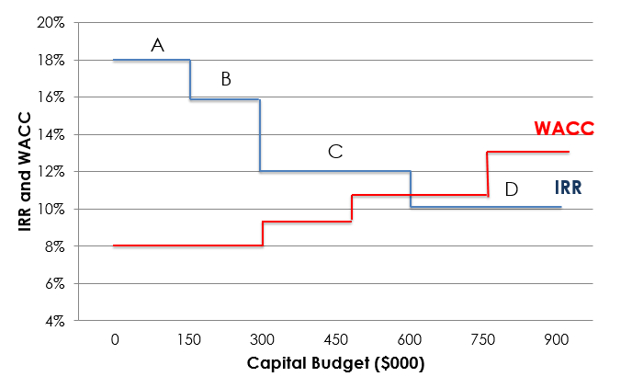
    - Choose not to fund all projects
Point of intersection of IRR and WACC is the optimal capital budget (600,000), will accept projects A, B and C.
However, if company only has 400,000, they will choose to undergo capital rationing and only accept projects A and B

Lecture 10: Capital Structure and Leverage
Capital Structure
- 2 main sources: Debt and Equity (with hybrid financing in between – preferred stock)
- Capital structure refers to the % of debt, preferred stock and common equity that is used to finance a firm’s assets
- Debt to Capital Ratio = Debt / (Debt + Equity + Preferred Stock)
Business Risk and Financial Risk
Business Risk
- Risk inherent in a firm’s operations – uncertainty about future operating income (EBIT)
- Measured using the SD of EBIT
- EBIT = Sales – Operating Cost = Quantity*Price – Operating Cost
- Uncertainty about demand, o/p prices, costs, products & liabilities, operating leverage
  - Operating leverage is the use of fixed costs rather than variable costs
  - In general, more fixed cost = more operating leverage = more risk
    - A small sales decline can cause a big EBIT decline
    - If use variable costs, sales decline = costs decline, which is not the case when fixed cost is used
Trade-off!
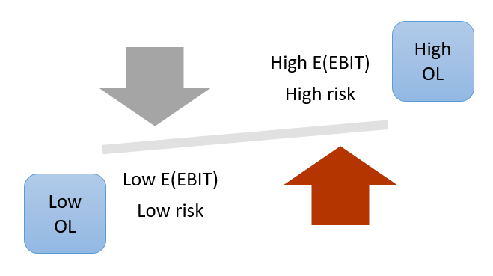
    - Hence, higher business risk comes with higher operating costs (EBIT)

Financial Leverage and Financial Risk
- The use of debt and preferred stock which incurs fixed financial charges
- Additional risk concentrated on common stockholders because of financial leverage
  - There’s interest (debt) and dividends (preferred stock)
  - More debt, more financial risk
Optimal Capital Structure
- The capital structure at which stock price is maximised
  - Stock price is affected by both future CFs and the risk of CFs
  - There’s a trade-off: higher expected profitability v higher risk when increase debt
- Hence, goal is to find the stock price at each level of debt, and the debt level that maximises stock price is the optimal capital structure
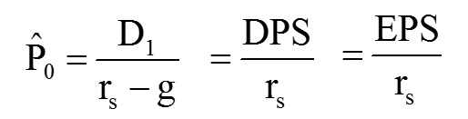
How to determine the impact of changing capital structure on stock price?

- If all earnings paid out as dividends, growth rate = 0
  - g = (1 – dividend payout) x ROE
  - When all earnings paid out as dividends, dividend payout = 1
- EPS = DPS
- To find expected stock price, must find the EPS and appropriate r_{s} at each debt level
Finding the Optimal Capital Structure
- Recapitalisation
- New debt is issued
- Proceeds from debt issuance is used to repurchase stock
  - Total capital does not change!
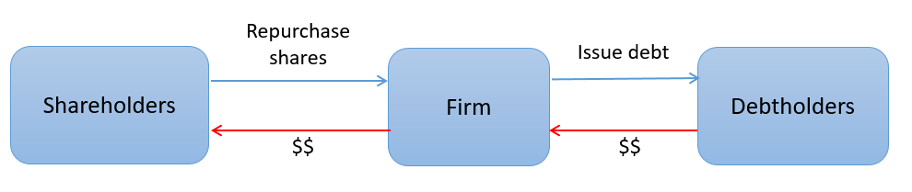
  - Number of shares repurchased = amount of debt issued / price per share

Case Study: Cheetah Café Company
- Cheetah Café company is currently an all-equity firm with no debt, no preferred stock.
- It has total capital of $2 million, shares outstanding = 80,000
- EBIT = $400,000, tax rate = 40%.
- Shares can be repurchased at the current market price of $25
- So how does the change in structure (amount of debt) change stock price?

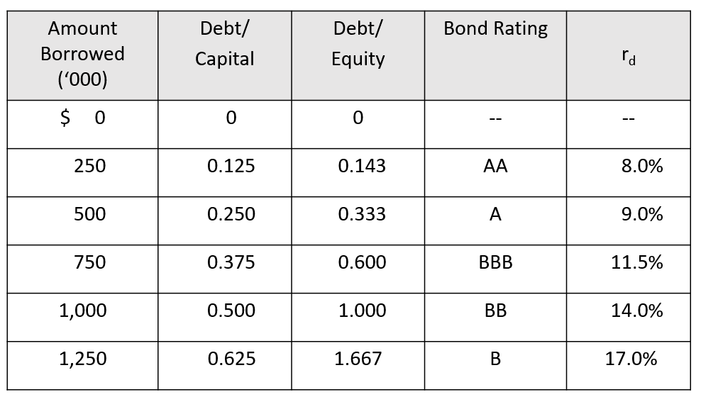
Cost of Debt at Different Debt Ratios
As debt increase, bond rating decreases due to the increase in likelihood of default
Hence, cost of debt (r_{d}) increase since there is increase in default risk
With worsening credit ratings, bondholders require a higher return!

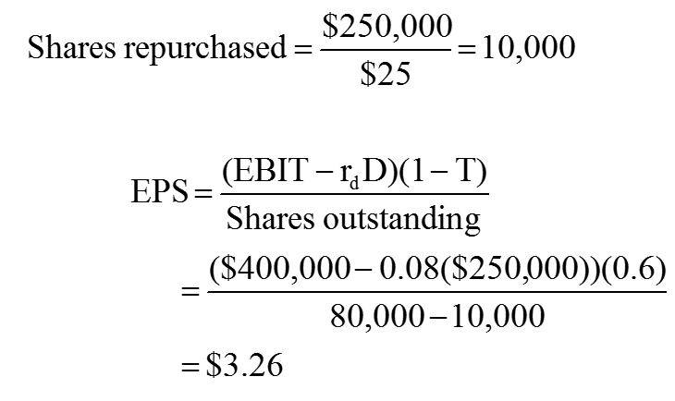
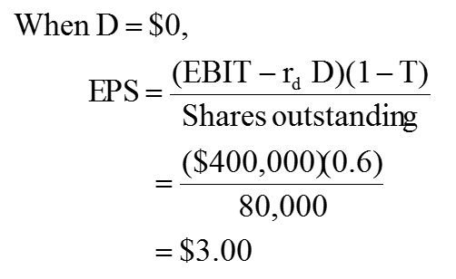
Determining EPS
*etc etc – use this method to calculate for all other values
What should be the optimal capital structure?
- Should not set at the ratio where the EPS is maximised! Because high EPS also means higher risk!
- Higher financial leverage -> high EPS, but also -> higher financial risk -> higher required return -> higher cost of equity (from CAPM model)
- Beta (in the CAPM model) changes, hence have to find the change in beta!
  - Hamada Equation
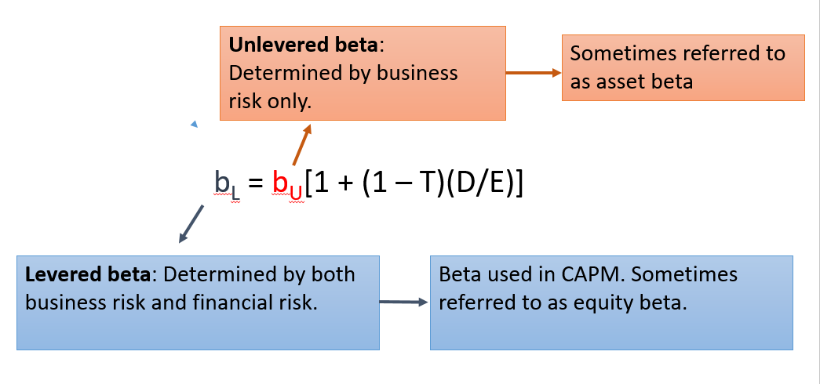
Hamada Equation
- For instance, using the Cheetah example + RF rate 6% as MRP, current beta 1.0
- If D = $250
  - b_{L} = 1.0[1 + (0.6)($250/$1,750)] = 1.0857
  - r_{s} = r_{RF} + (r_{M} – r_{RF})b_{L}
= 6.0% + (6.0%)1.0857 = 12.51%
*etc etc – use this method to calculate for all other values

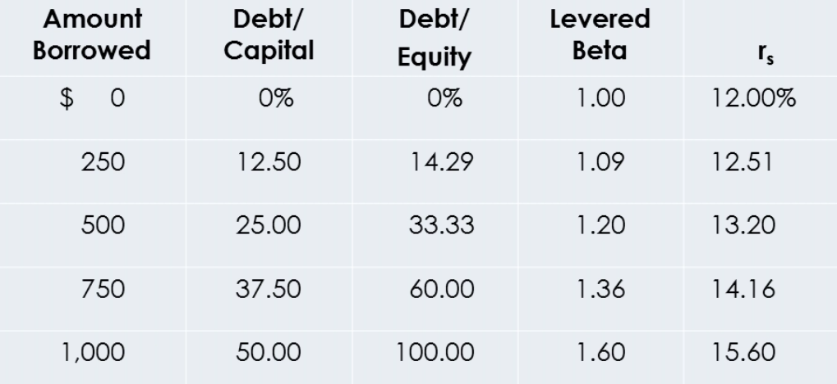

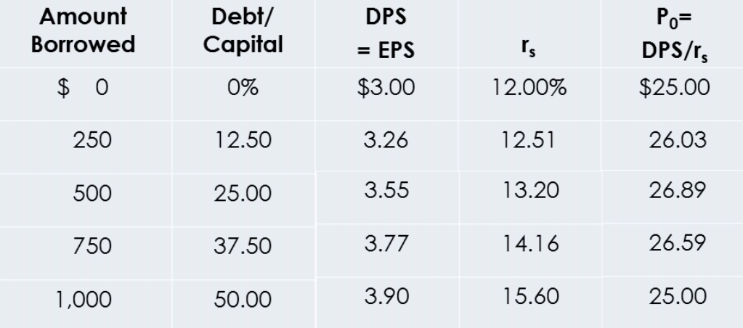

2 Methods to find the Optimal Capital Structure
- Max stock price
- Min WACC
- Both same results!
- But it is not easy to find because values are estimated
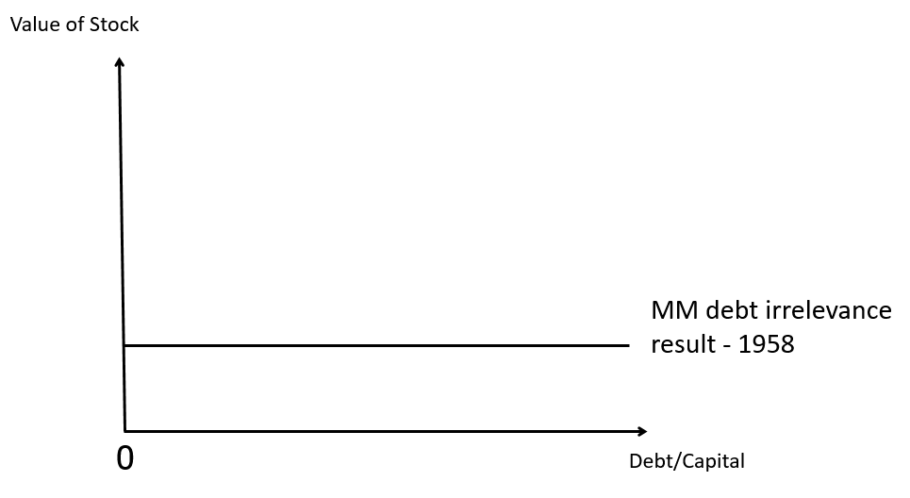
Modigliani-Miller Irrelevance Theory
- “Stock price will not be affected by capital structure, but the quality of the investment”

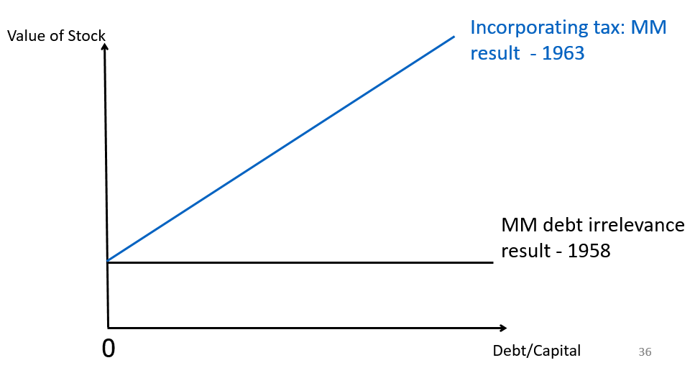
Relaxing Assumptions #1 – Tax Benefit of Debt
- Interest expense is tax-deductible -> pay less taxes
- But distributions to shareholders e.g. dividends, do not reduce taxes

Relaxing Assumptions #2 – Bankruptcy Costs
- Expected bankruptcy costs depends on:
  - Probability of bankruptcy: How volatile is your future cash flow?
  - Actual costs incurred when in bankruptcy: Legal and accounting fees, liquidation of assets at fire-sales, loss of customers, suppliers, employees, etc
  - Indirect costs due to the threat of bankruptcy: Customers and suppliers refuse to do business with the firm because they think that the firm may go bankrupt anytime
But, there’s a trade-off between tax benefits and bankruptcy costs
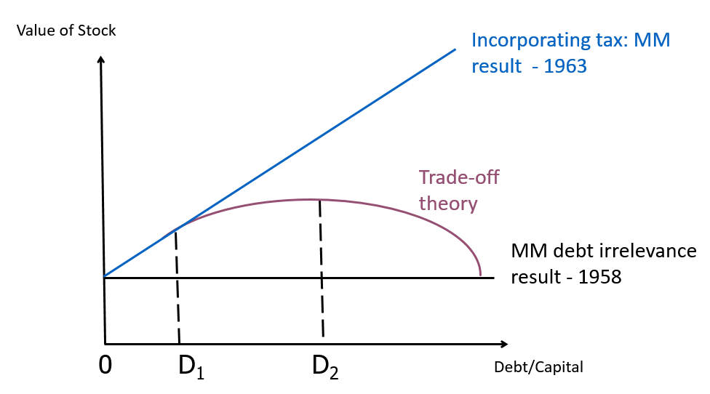

Relaxing Assumptions #3 – Signalling Costs
- Managers have more information than outside shareholders
- Signalling theory suggests firms use less debt than what trade-off theory suggests
- This unused debt capacity helps avoid stock sales, which depress stock price because of signalling effects
  - To avoid issuing equity which may send a bad signal to the market
  - Why?
If need capital to finance project, and know that stock is overvalued: Sell equity (to obtain a good price for stock)
If know that stock is undervalued: Sell debt (to prevent selling equity at cheap price)
Hence, outside investors will think that the stock is overvalued that’s why managers are selling, hence they will sell -> fall in stock price
  - But what if have too much debt? Cannot have even more
    - Hence managers should maintain the unused debt capacity
Relaxing Assumptions #4 – Agency Costs
- Debt can constrain managers because the managers must now make sure they earn enough to cover the regular interest payments. Failing to do so, may force the firms to go into bankruptcy and the managers will lose their jobs as a result
Lecture 11: Distributions
Omit Residual Dividend Model
Dividend Policy
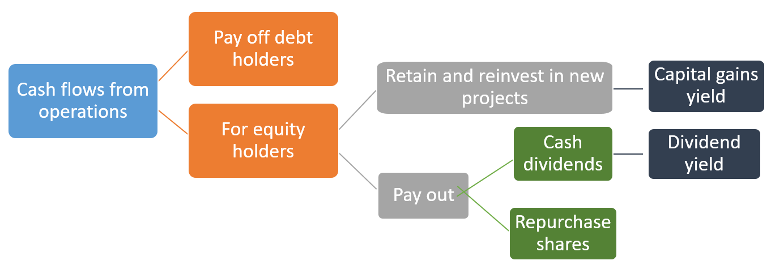
- Has to do with the decision of whether to pay dividends vs retaining funds to reinvest, and also the decision to pay back using cash dividends or repurchase shares
Optimal Dividend Policy
- Should maximise stock price
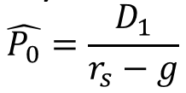
- Increasing dividend has 2 opposing effects on the stock price
  - Increase D₁ – upward pressure on stock price
  - Decease g – downward pressure on stock price
  - R_{s}?
- When D increases, g decreases since there are less cash for investments
- Net effect?
Dividend Irrelevance Theory
- Dividends do not impact stock price (assume perfect world)
- Stock price is determined only by the earning power and risk of its assets (investments)
- Investors are indifferent between dividends and retention-generated capital gains
- Investors can create their own dividend policy
  - If want cash, sell stock
  - If do not want cash, can use dividends to buy stock – self-made capital gains
- Implication: Any payout is okay
Preference for Dividends
Bird-in-Hand Theory
- Investors may think dividends obtained today are less risky than potential future capital gains, hence prefer dividends
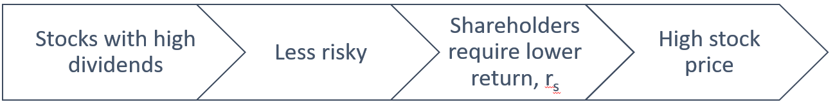

- Implications: Set a high payout

Preference for Capital Gains
- Some investors may want to save for long term – don’t want dividends, and when they use dividends to buy more shares, may incur transaction costs
- Hence, prefer capital gains – avoid these transaction costs
Tax Issues
- Tax advantages of capital gains:
  - Capital gains usually taxed at a lower rate than dividends (depends on tax regime)
  - Taxes are due in the year they are received (dividends) vs due when the stock is sold (capital gains)
  - Favorable capital gains tax treatment on inherited stock
- Dividends have a tax disadvantage relative to capital gains -> prefer capital gains
- Implication: Set a low payout
If a firm pays out all its earnings as dividends and its stockholders then elect to have all their dividends reinvested, the company should reconsider its dividend policy and possibly move to a lower dividend payout ratio – TRUE (if retain earnings, its CGY – taxes will be deferred until stock is sold)
Signalling Effects
Stock Price Reactions to Dividend Changes
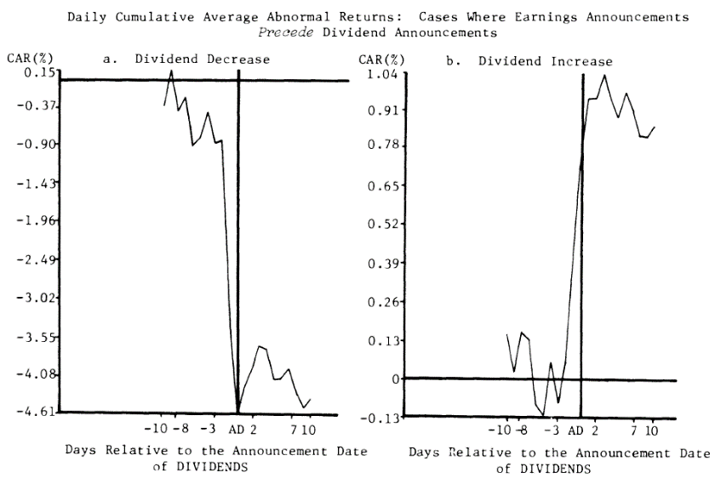

Shows that shareholders prefer dividends

Signalling Hypothesis
- Investors view dividend changes as signals of management’s view of the future
- Since managers hate to cut dividends, they will not raise dividends unless sustainable
  - Since a dividend cut will cause a fall in stock price
- Therefore, a stock price increase at the time of a dividend increase could reflect higher expectations for future EPS, not a preference for dividends
  - If increase dividends, means that they are confident that they will not need to cut dividends in the future (think they will do well)
  - Since investors think that managers will only cut dividends as a last resort
  - Cut is bad

Clientele Effect
- Different groups of investors, or clienteles, prefer different dividend policies
- E.g. – Adults (regular salary) prefer capital gains, retirees (irregular) prefer dividends
- Firm’s past dividend policy determines its current clientele of investors
- Implication: Clientele effects impede (prevents) changing dividend policy, since the taxes and brokerage costs will hurt investors who have to switch companies
Other Distributions
Dividend Reinvestment Plans (DRIP)
- Shareholders choose to receive the cash dividends or to have the company use the dividends to buy more stock in the firm on behalf of the investor
  - Shareholders can automatically reinvest their dividends in shares of the company’s common stock
  - Get more stock than cash
- There are two types of plans: Open market; New stock
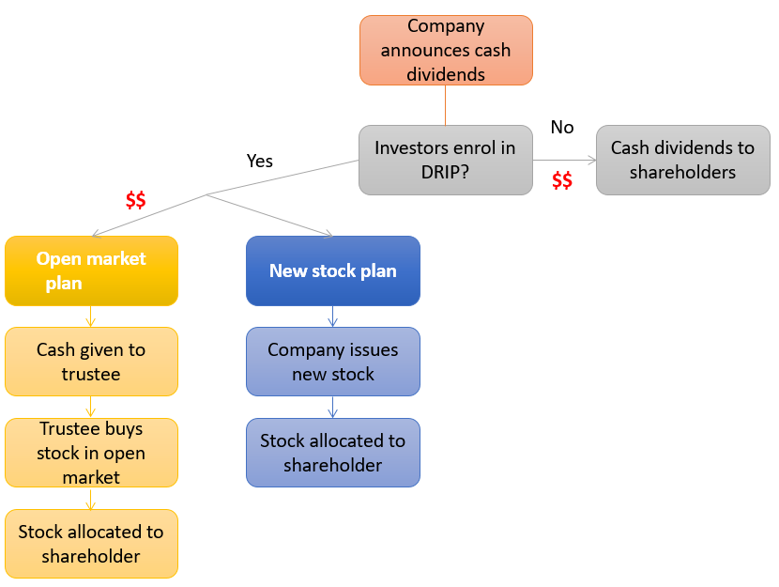

- DRIP: Open Market Purchase Plan vs. New Stock Plan
  - Open market purchase plan: Dollars to be reinvested are turned over to the trustee who buys shares on the open market
    - Brokerage costs are reduced by volume purchases; convenient and easy
  - New stock plan: Firm issues new stock to DRIP enrollees (usually at a discount from the market price), keeps money and uses it to buy assets
    - Discount to entice shareholders
    - Helps conserve cash; companies that need capital use new stock plans
      - Useful for cash-strapped companies
Stock Repurchase
- When companies decide to pay out cash, they can choose to pay cash dividends or buy back own stock from stockholders – reduce shares outstanding
- Shares bought back are held as treasury stock and can be resold in the future to raise capital
- Advantages relative to cash dividends:
  - May be viewed as a positive signal that the management thinks stock is undervalued
  - Shareholders can choose to sell or hold
  - Repurchases can be used to dispose off temporary excess cash flows and avoid setting high dividend payout
  - Can be used to make large capital changes
- Disadvantages relative to cash dividends:
  - May be viewed as a negative signal that the firm has poor investment opportunities
  - Cash dividends are dependable but repurchases are not
  - Firm may have to bid up price to purchase – pay too much for own stock
Stock Dividends & Stock Split
- Stock dividend: Firm issues new shares in lieu of paying a cash dividend.
  - If a 10% stock dividend is announced, shareholders get 10 shares for each 100 shares owned
  - Shares outstanding increases
- Stock split: Firm increases the number of shares outstanding, say 2:1 (shareholders get more shares)
  - Market value of equity doesn’t change! Remains
- Stock dividends and stock splits increase the number of shares outstanding, so “the pie is divided into smaller pieces”
- Unless the stock dividend or split conveys information, the stock price falls so as to keep each investor’s wealth unchanged
- But splits/stock dividends may get us to an “optimal price range”
  - Optimal price range for stocks is $20 to $80. Stock splits and stock dividends can be used to keep the price in this optimal range
- Effect on Firm’s Value
  - Stock splits and stock dividends are viewed as positive signals that the management is confident about future earnings – increase in stock price
  - By creating more shares and lowering the stock price, stock splits may increase stock’s liquidity and increase the firm’s value

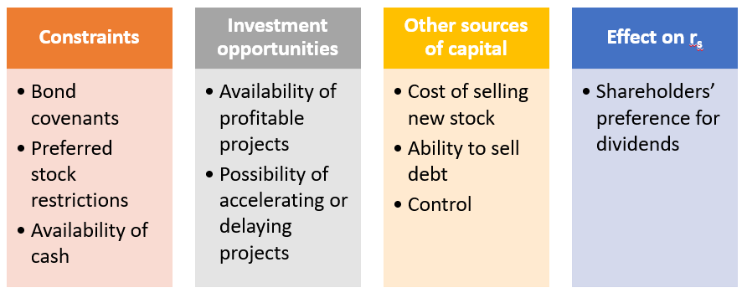
Other Considerations When Setting Dividend Policies

Qn: Difference between DRIP’s new stock plan vs Stock Dividends?

